TS v-development Ltd. Tel: (852) 27578547



Fax: (852) 27578595

Web site: [www.tsvd.com.hk](http://www.tsvd.com.hk/)

Address: Room A7, 7/F, Blk A, Proficient Industrial Centre

6 Wang Kwun Road, Kowloon Bay, Hong Kong

**Job Reference**

# Central Control LED System Project

**Client: Immigration Department (The Government of the HKSAR)**

## 入境事務處 **(**香港特別行政區政府**)**

Location: 2/F Arrival Hall of Lo Wu Terminal Building, Immigration Department, Hong Kong

Details:

Develop and provides 50 nos. Dot Matrix LED board (Model 19264T-3.75) and 4-key keypad and install to each Immigration counter. User can change the message on any LED display board through the Central Control Computer (on duty office) . Beside, user also can change the message (on each counter) through 4-key keypad.

Dot Matrix LED board details:

Model: TURBO SYSTEM 19264T-3.75

Colour: Red, Green and Amber Resolution: 192 (w) x 64 (h) dots

LED module: Semi-Outdoor High Bright 3.75mm diameter Screen size: ~912mm (w) x 304mm (h)

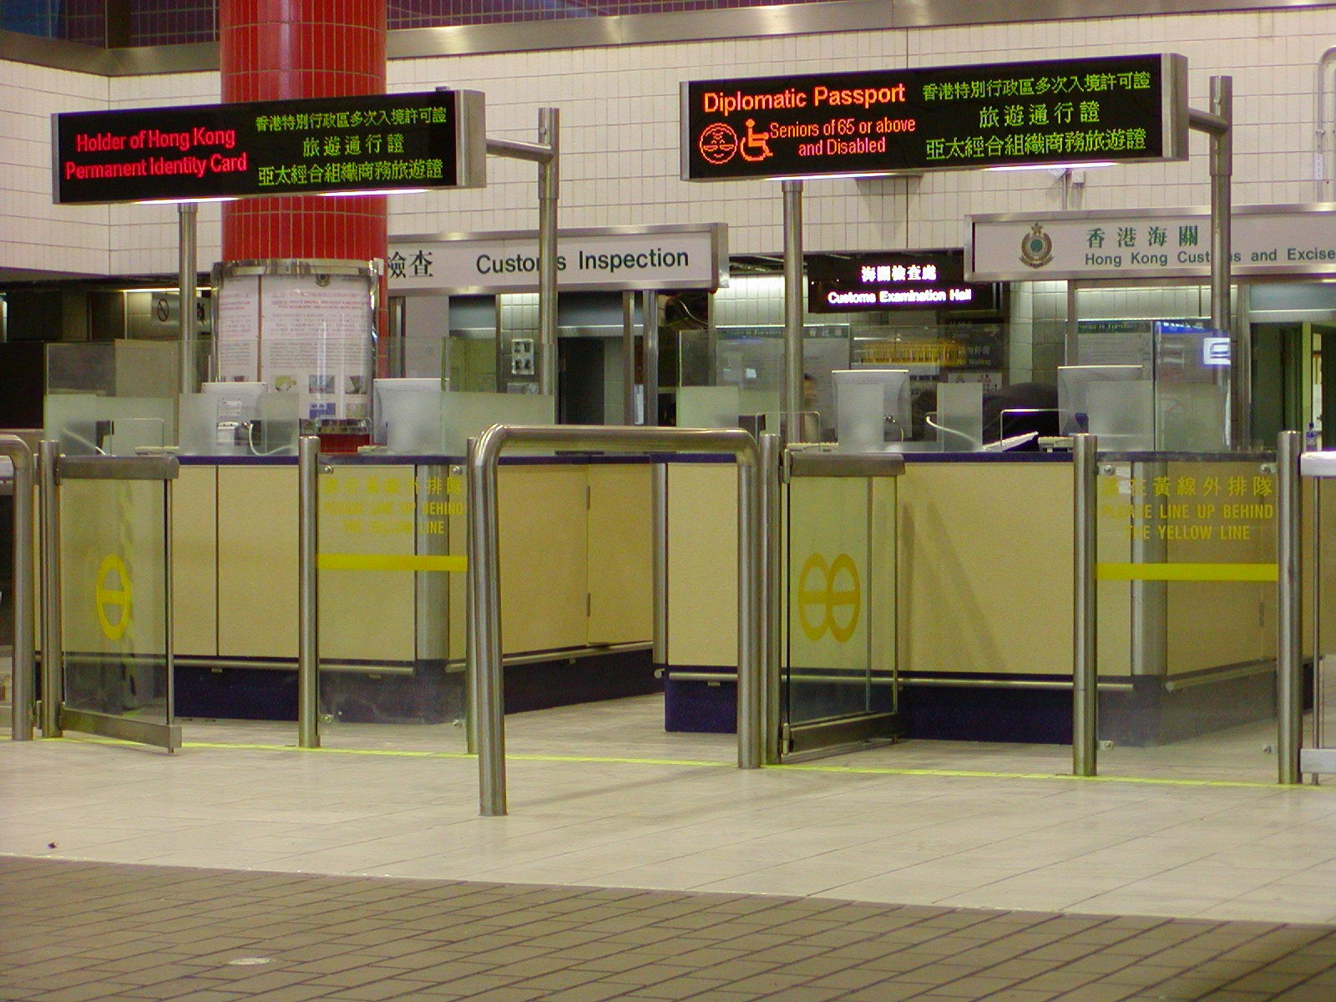

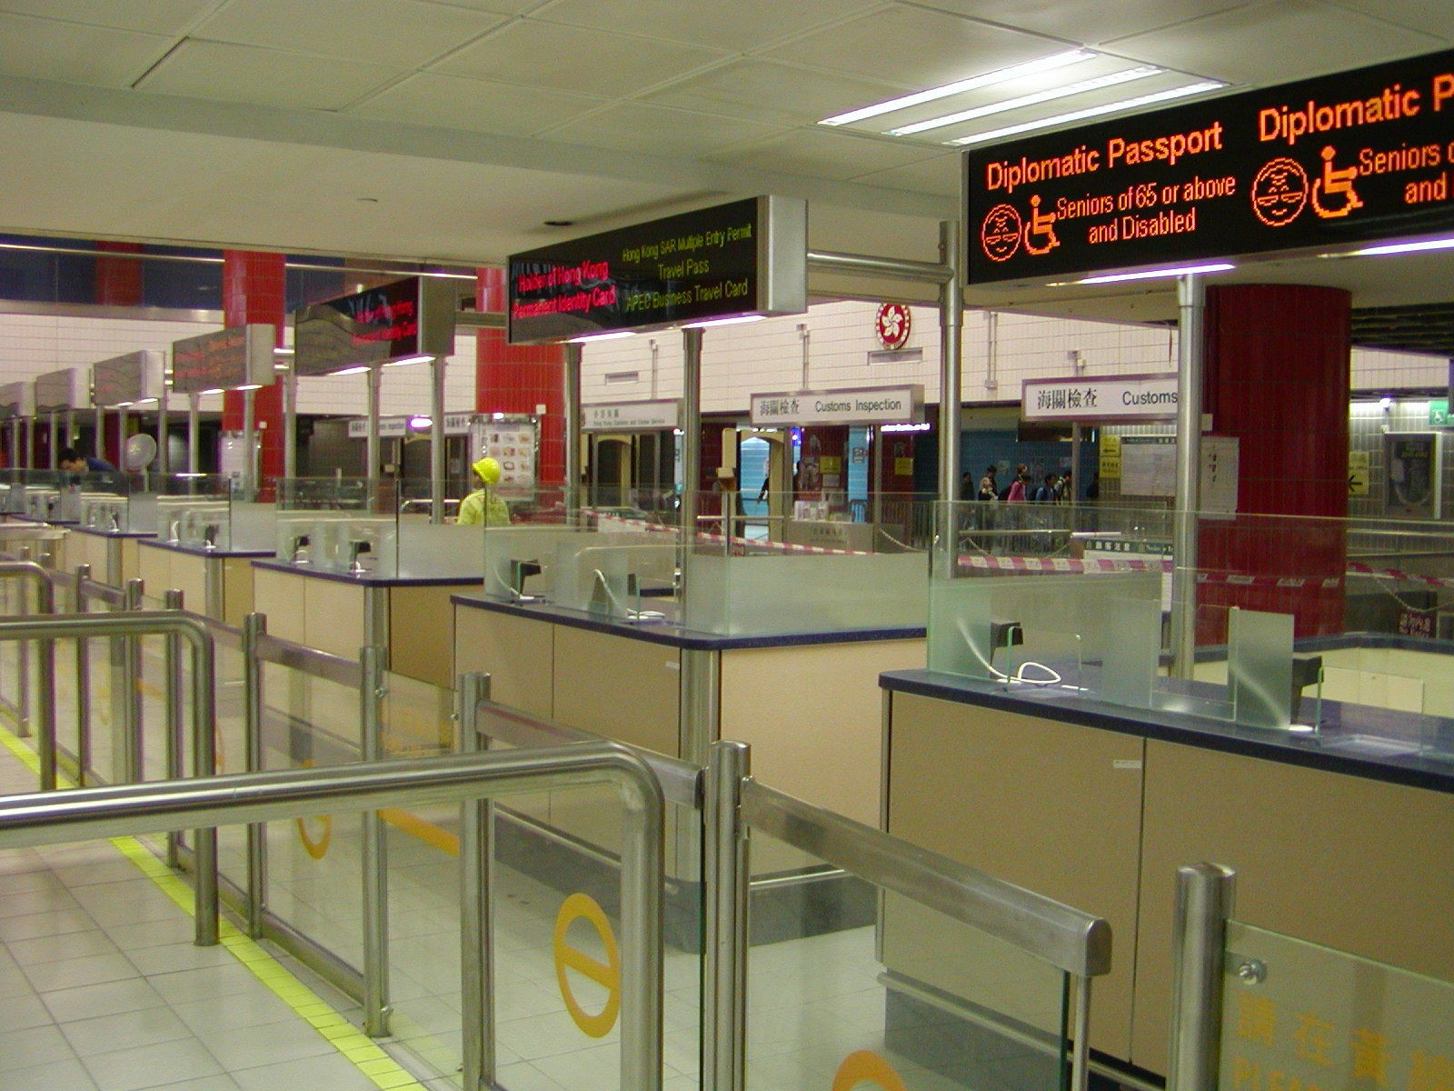

# Auto Queuing System Project

**Client: PCCW (**電訊盈科**)**

**PCCW Customer Service Center**

All branches in Hong Kong

 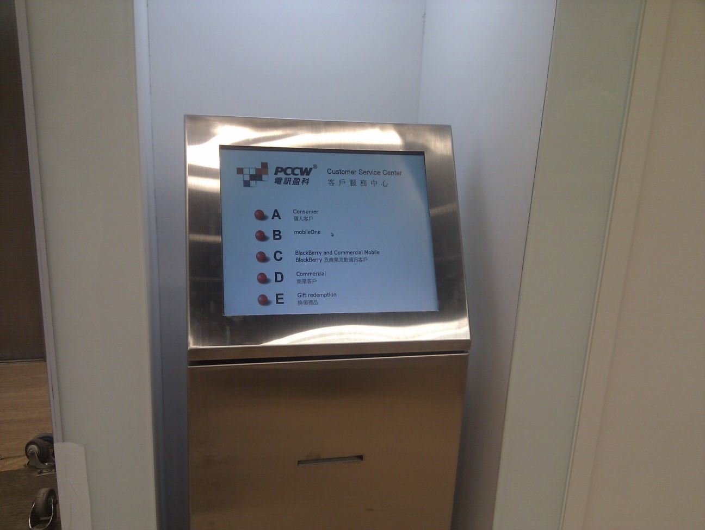

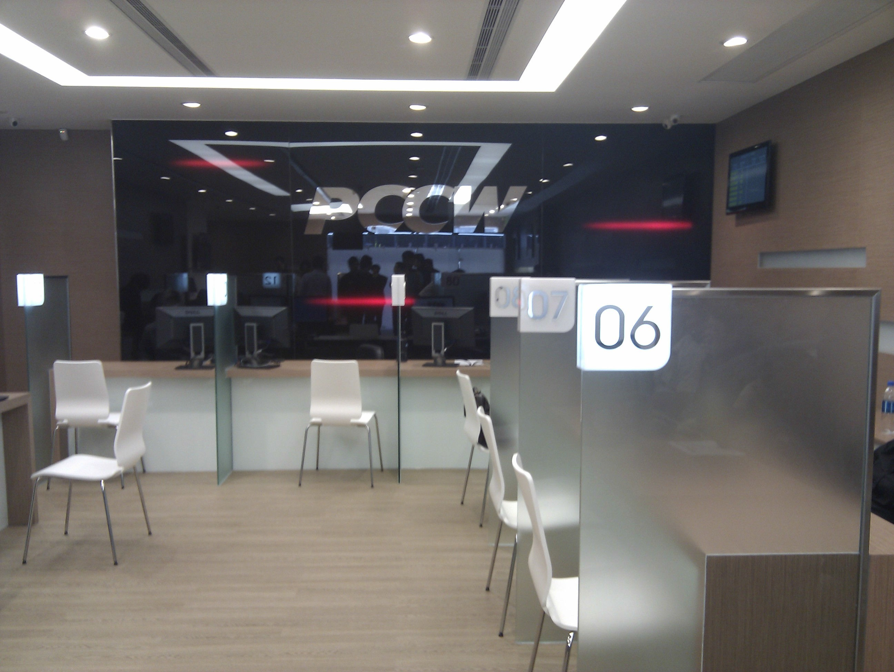

**Client: Hong Kong and China Gas Company Limited (**香港中華煤氣有限公司**)**

All branches in Hong Kong

Details:

Develop and custom-made an Auto Queuing System (AQS) to Hong Kong and China Gas Company Limited. AQS is content auto print out a ticket for user. Auto notices user go to which counter. More important is all the ticket time, queuing time and processing time will store in the database. User can print out the statistics report to see staff performance, customer service time, waiting time etc.

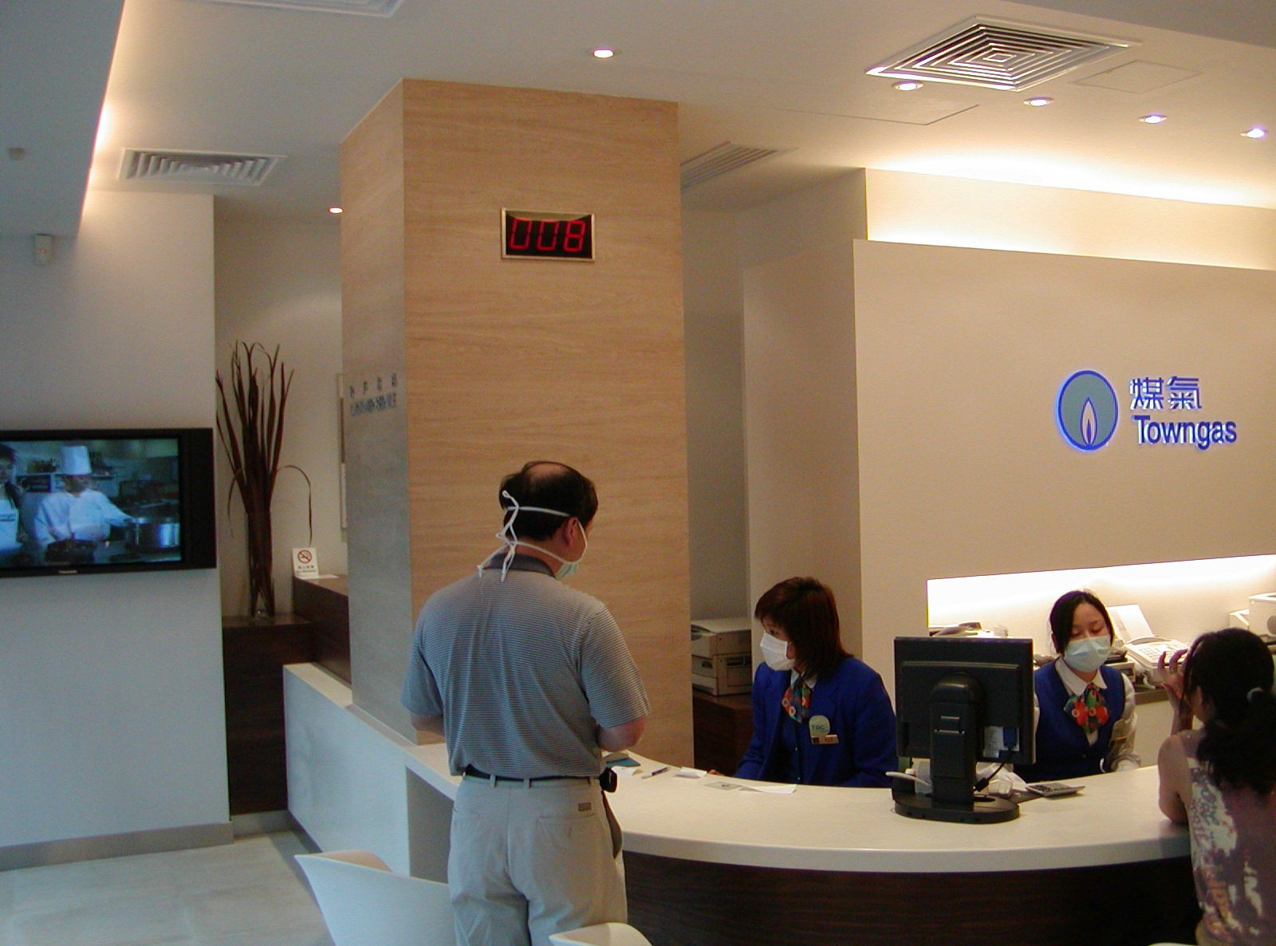

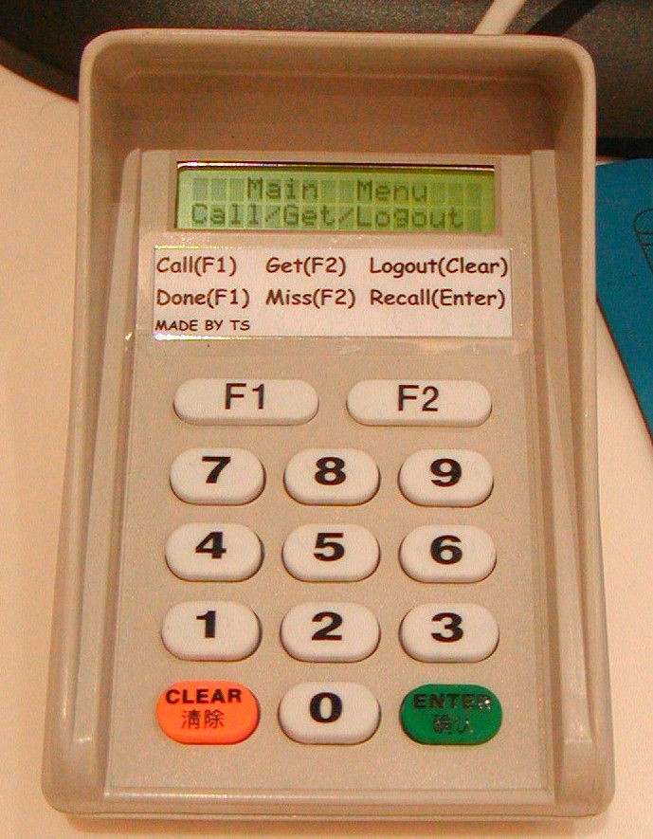

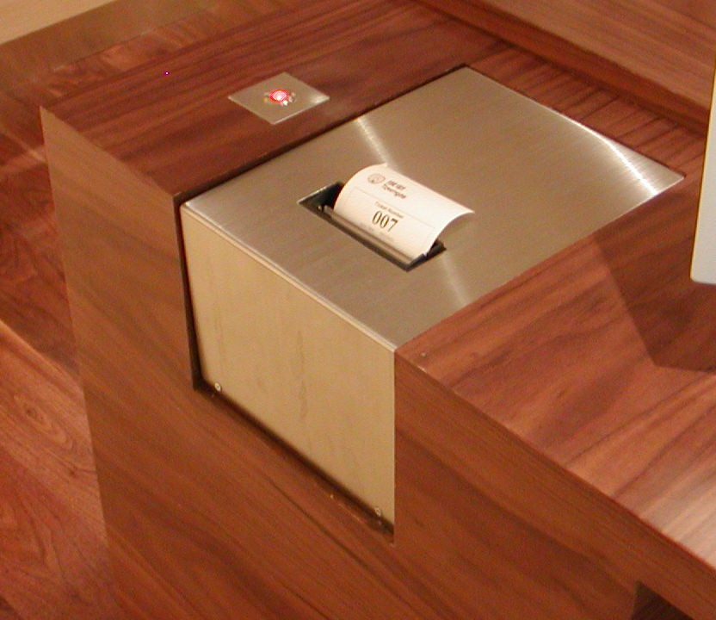

# Auto Queuing Project (Voice Announcement)

**Client: Inland Revenue Department (The Government of the HKSAR)**

## 稅務局 **(**香港特別行政區政府**)**

Location : 3/F, Revenue Tower, Wan Chai, Hong Kong Island

Customize and Design an Auto Queuing System to Inland Revenue Department. Specify function included Single query for multi process, different location printer ticket, Voice announcement, complex database etc...



**Client: Café de Coral Group (4G concept)** 大家樂集團有限公司

Location: All branches in Hong Kong

Details:

We cooperate with Café de Coral Group to develop the 4 Generation (4G) post-modern design concept. Provide customer Hotel-style comfort and elegance in Cafe restaurants.

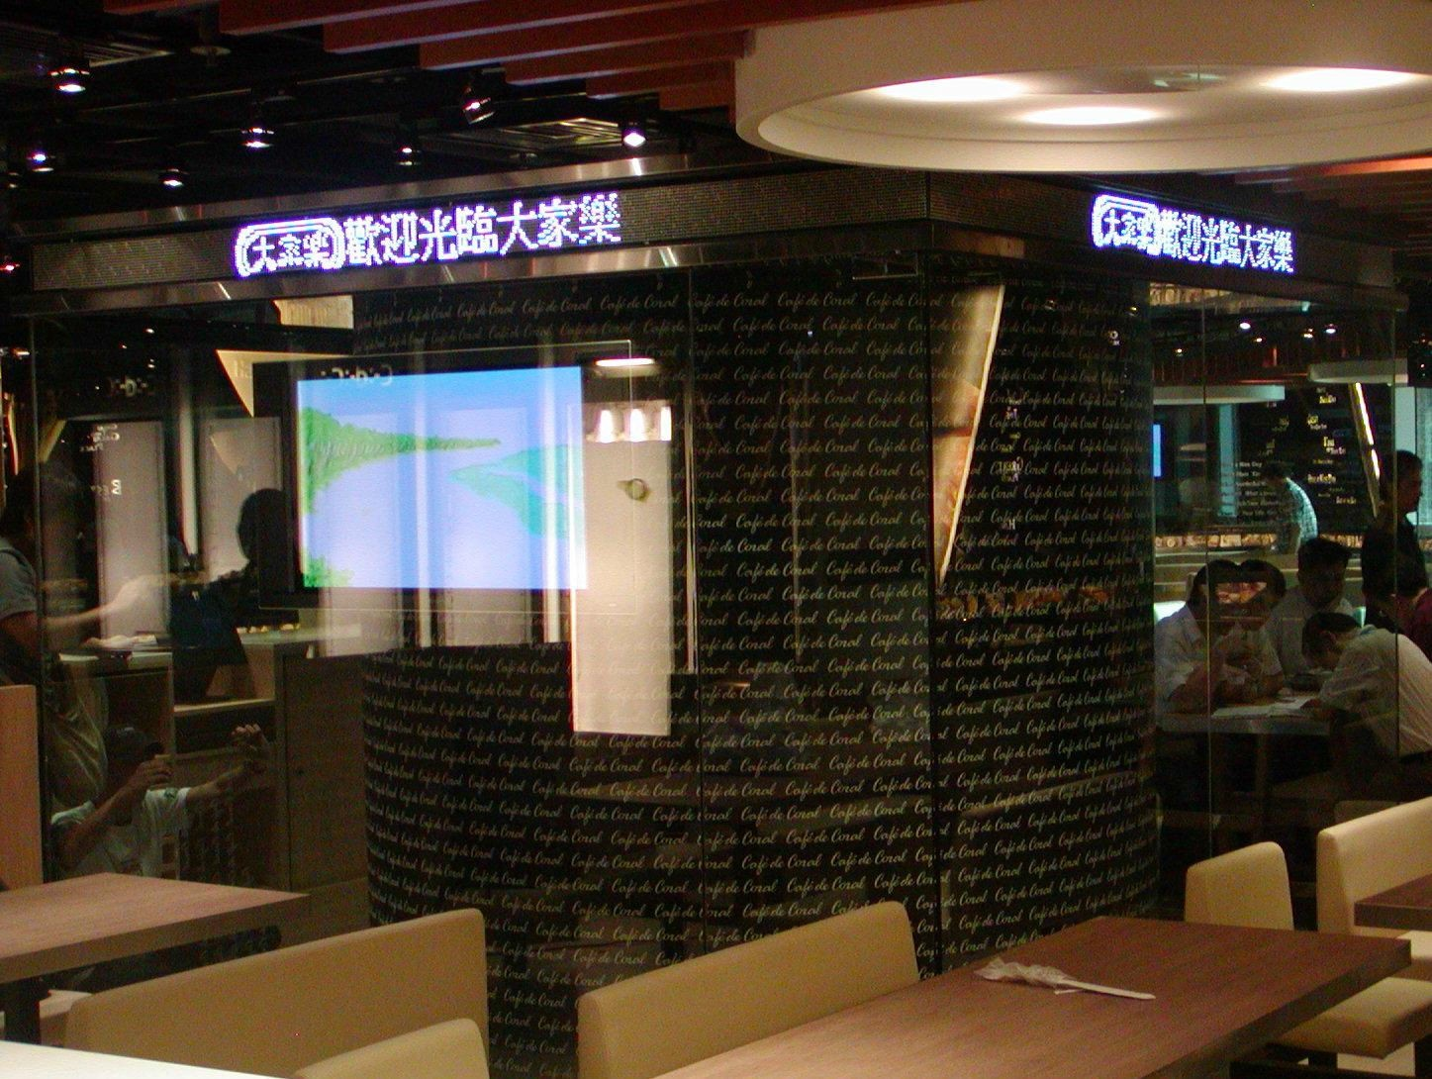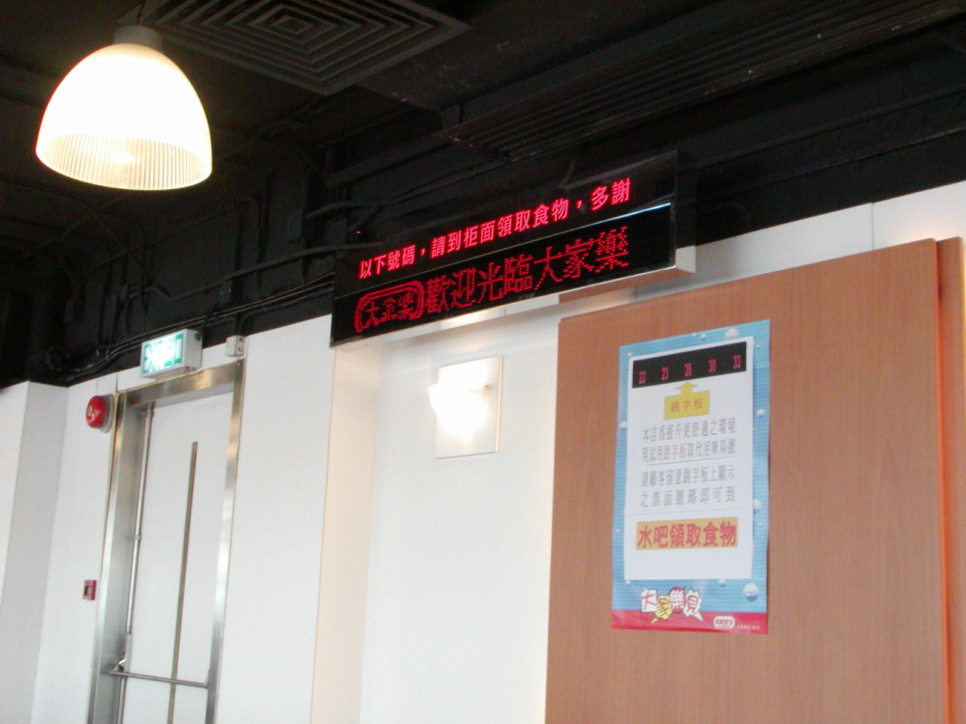

**Client: Rating and Valuation Department (差餉物業估價署)**

Location: 15th floor, Cheung Sha Wan Government Offices, 303 Cheung Sha Wan Road, Kowloon

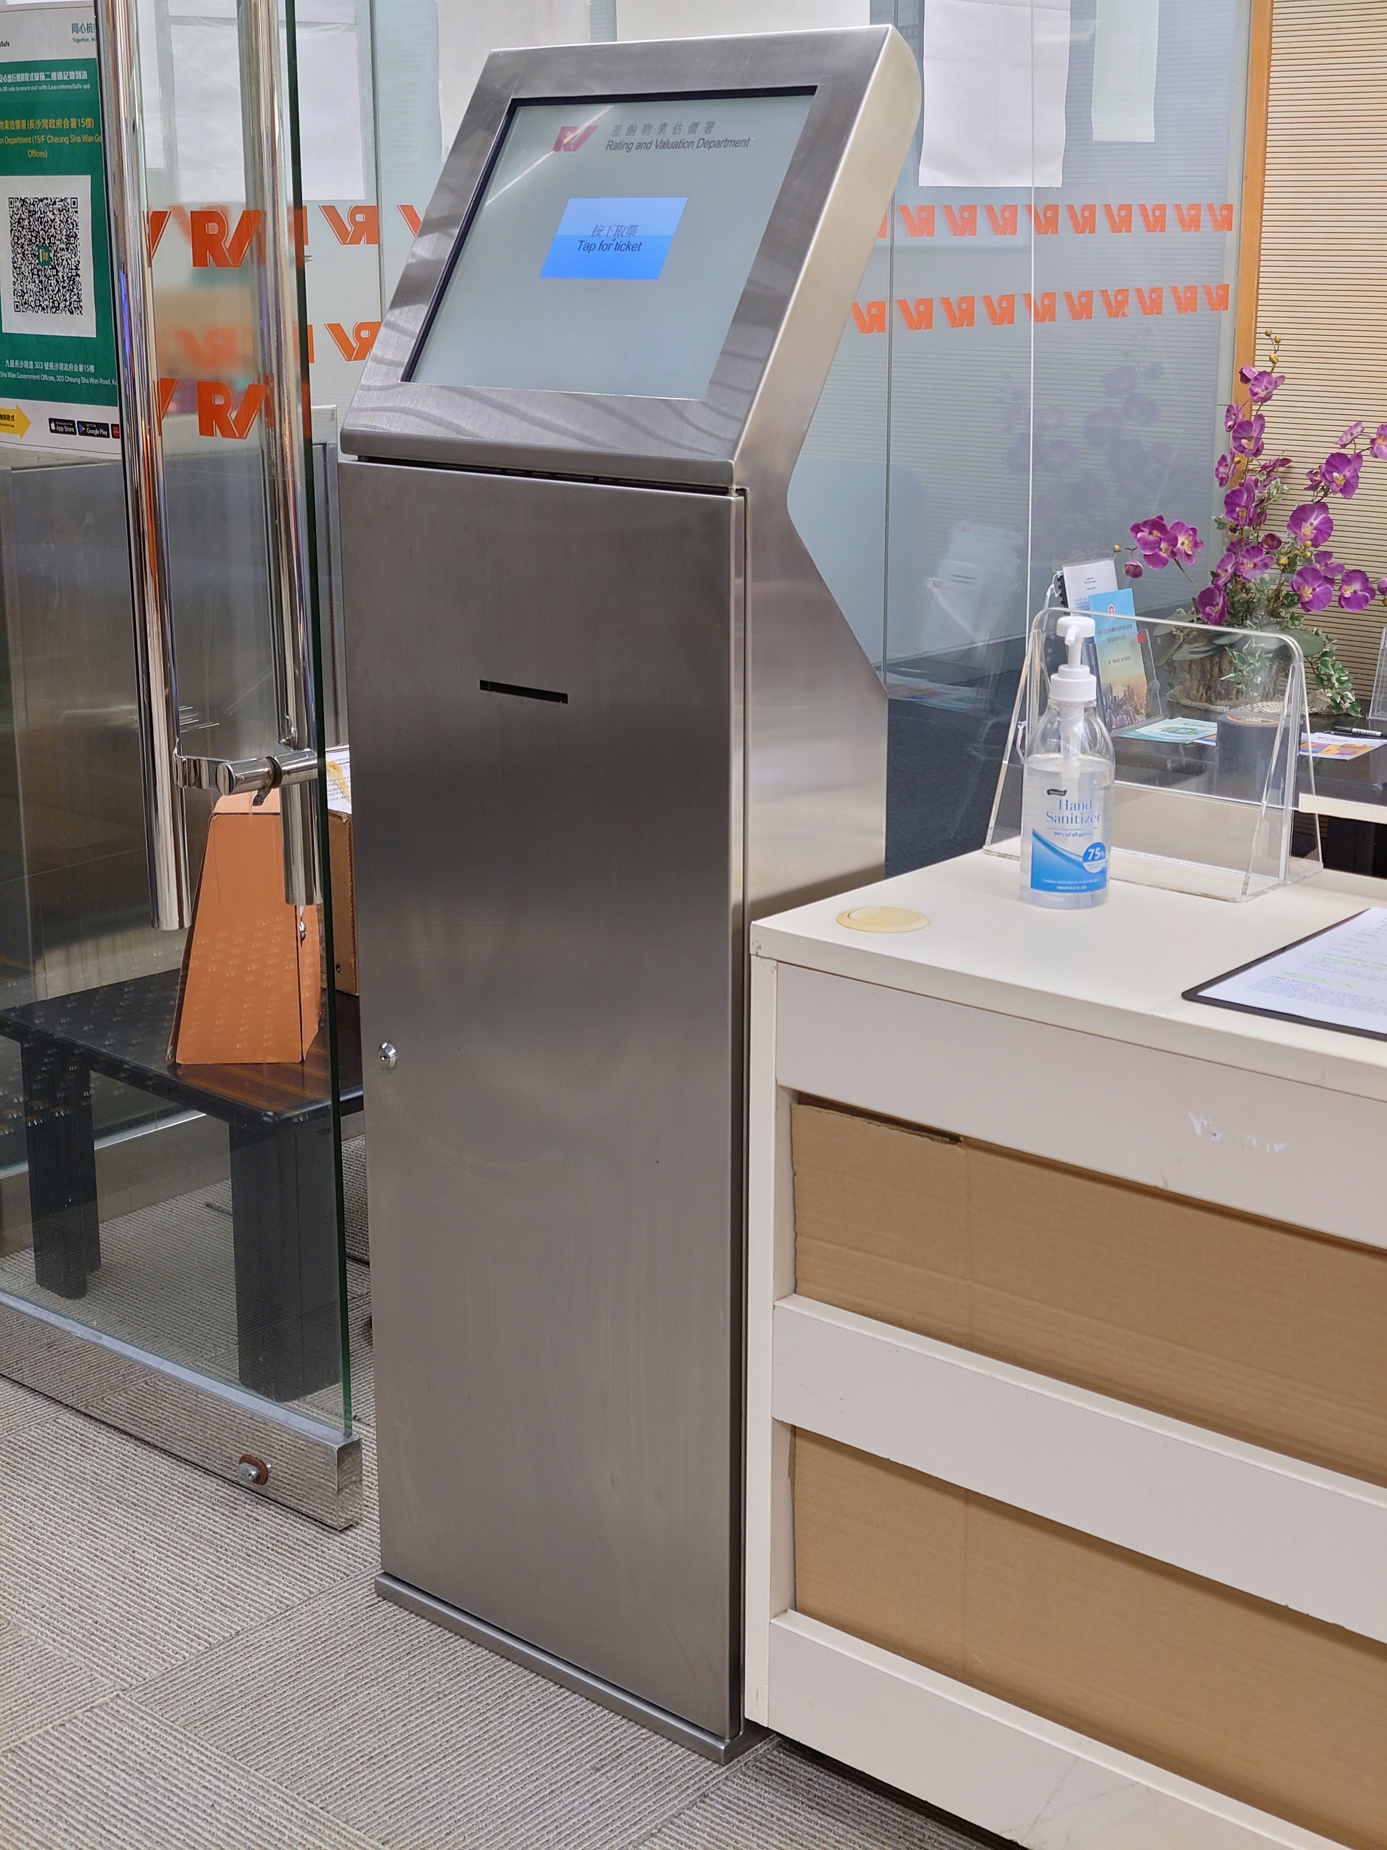

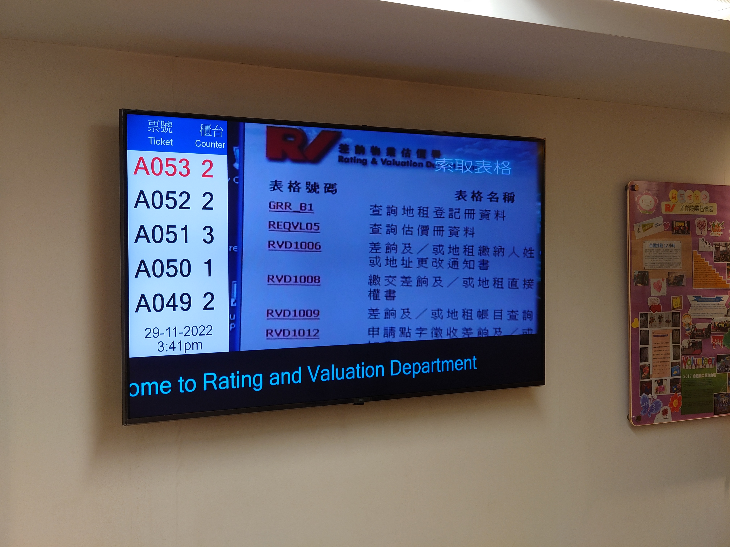

**Client: Company Registry (**公司註冊處**)**

Location: Unit 1208, 12/F, One Kowloon, 1 Wang Yuen Street, Kowloon Bay, Kowloon, Hong Kong

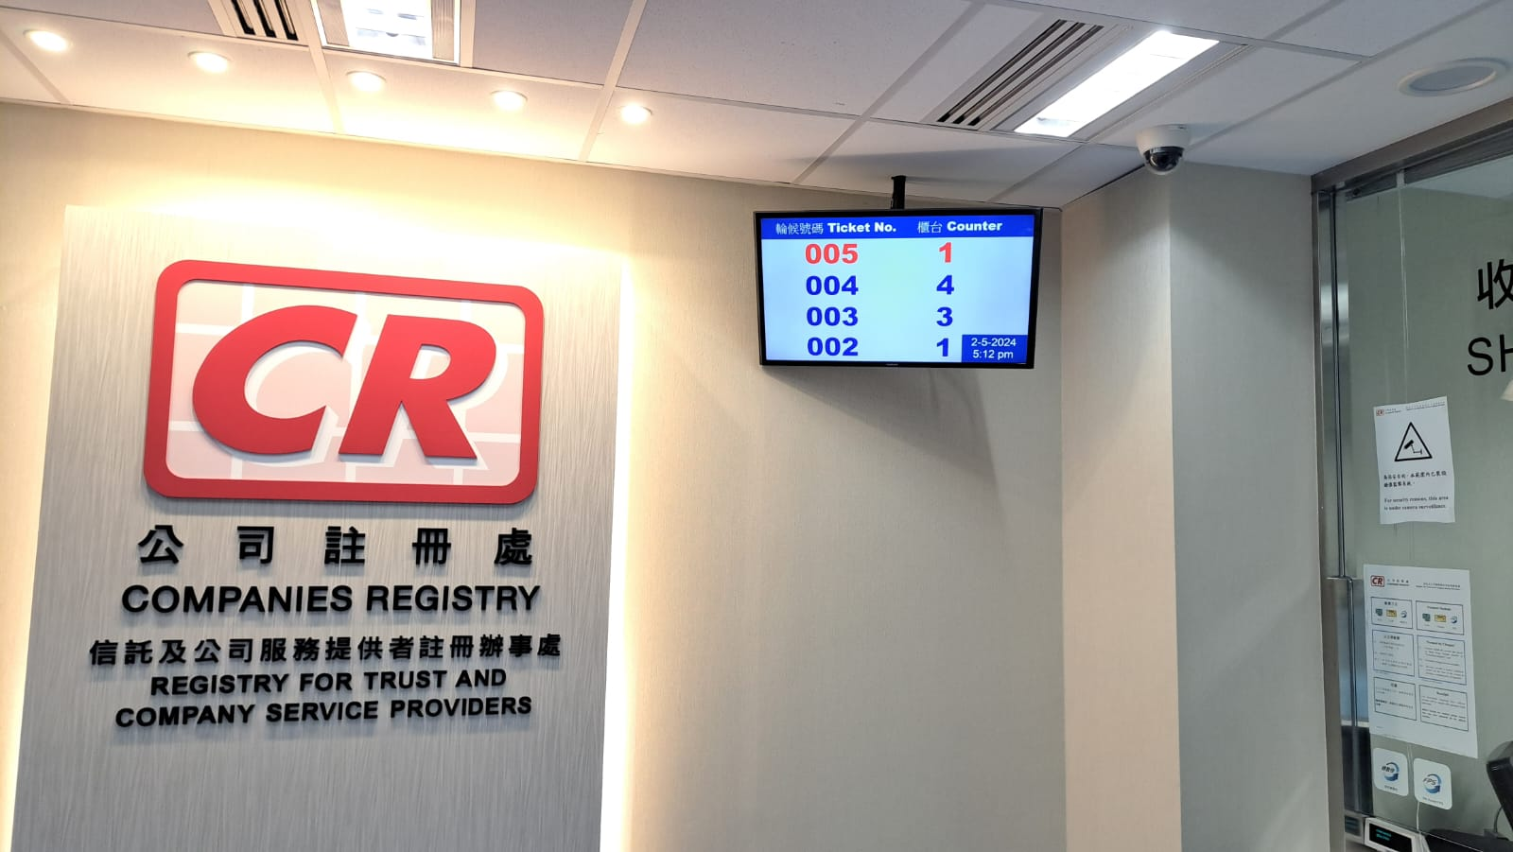

**Client: GIA Hong Kong Laboratory Limited (GIA 香港鑑定所有限公司)**

Location: 20/F, Goldin Financial Global Centre, 17 Kai Cheung Rd, Kowloon Bay

Location: Room 1108, New World Tower, 16-18 Queen's Road Central

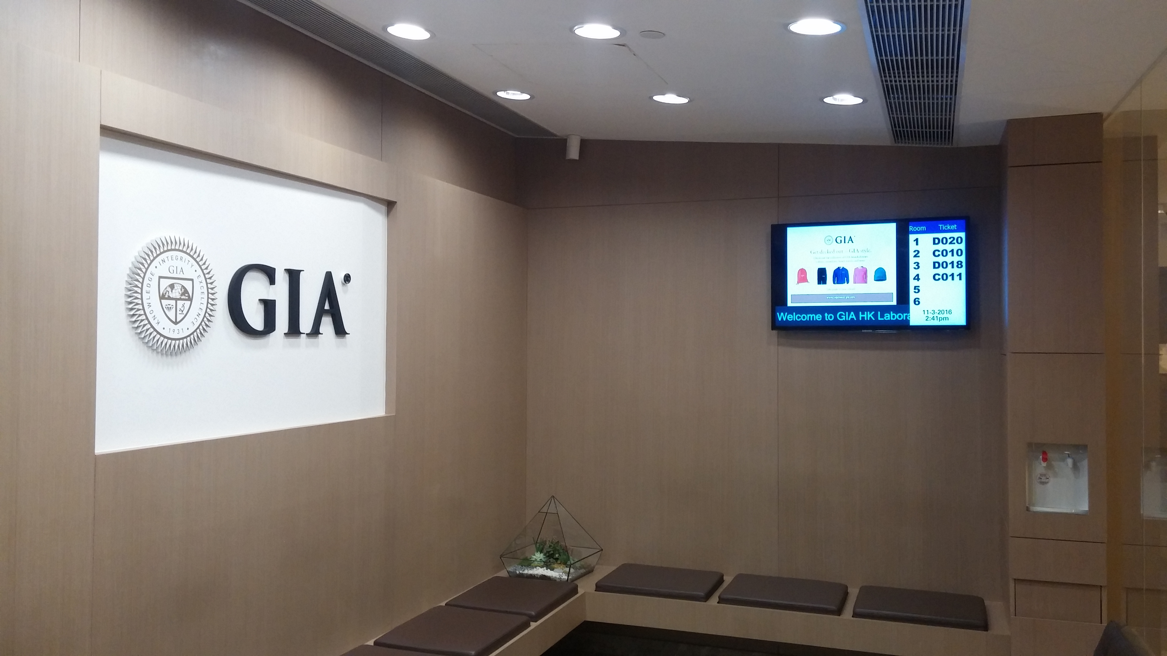

**Client: Christian Family Service Centre (基督教家庭服務中心)**

Location: Shop 1A, 3 Tai Yau Street, Maxgrand Plaza, San Po Kong

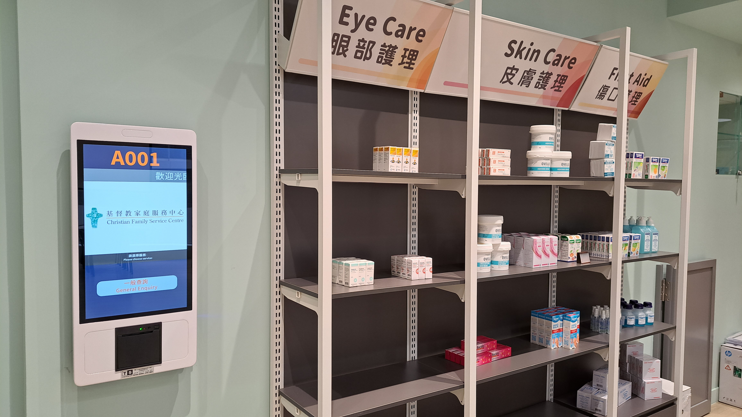

**Client: Roche Diagnostics (Hong Kong) Limited (羅氏診斷(香港)有限公司)**

Location: Level 17, Tower 1, Metroplaza, 223 Hing Fong Road, Kwai Chung, Hong Kong

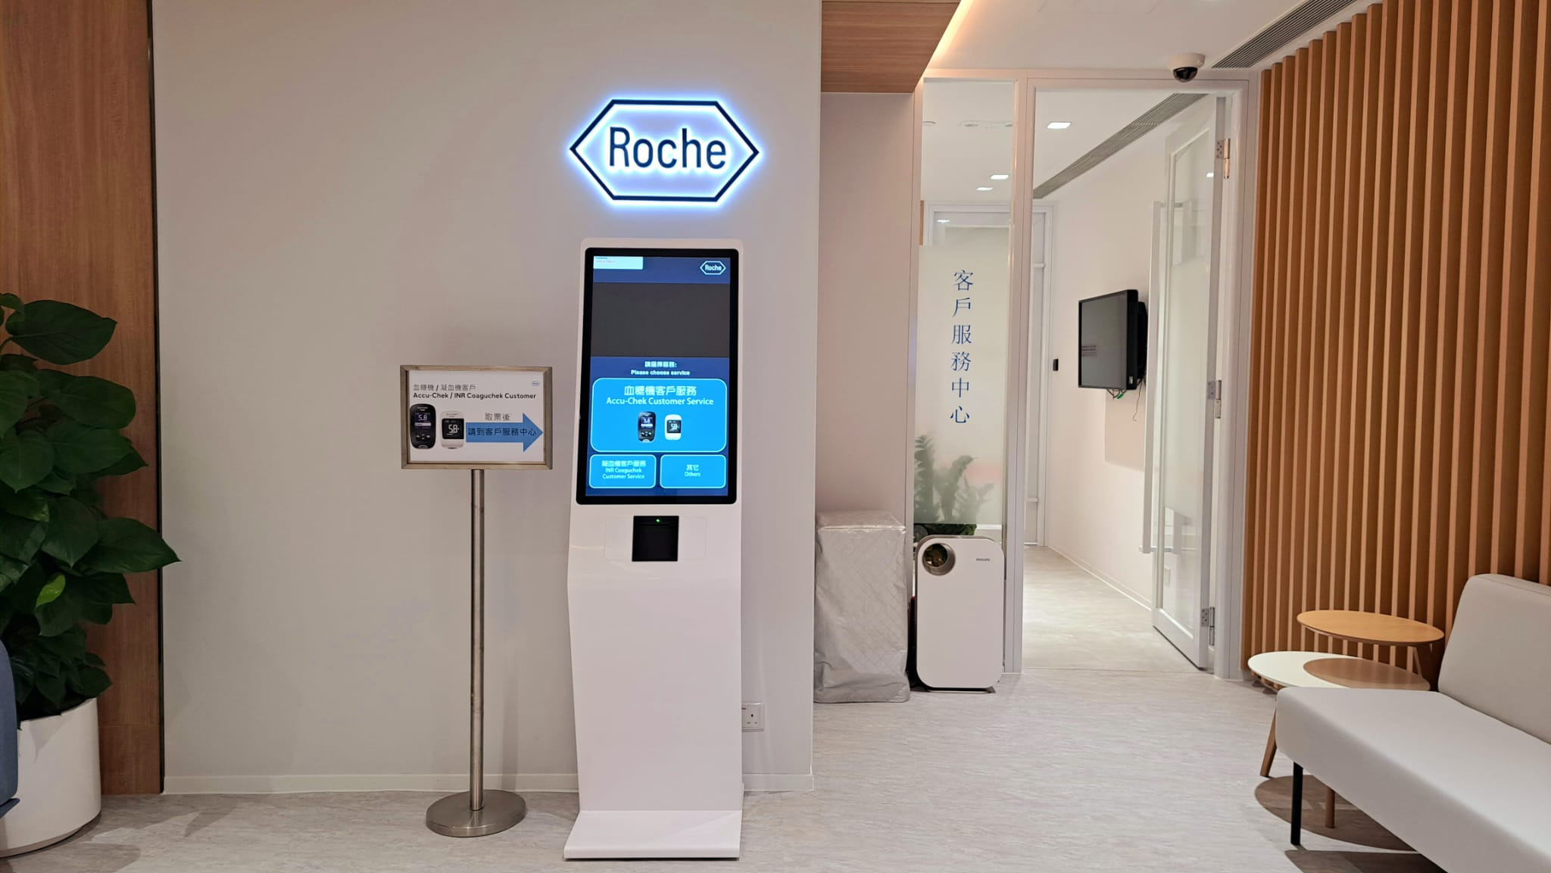

**Client: Bose Limited**

Location: Level 17, Tower 1, Metroplaza, 223 Hing Fong Road, Kwai Chung, Hong Kong

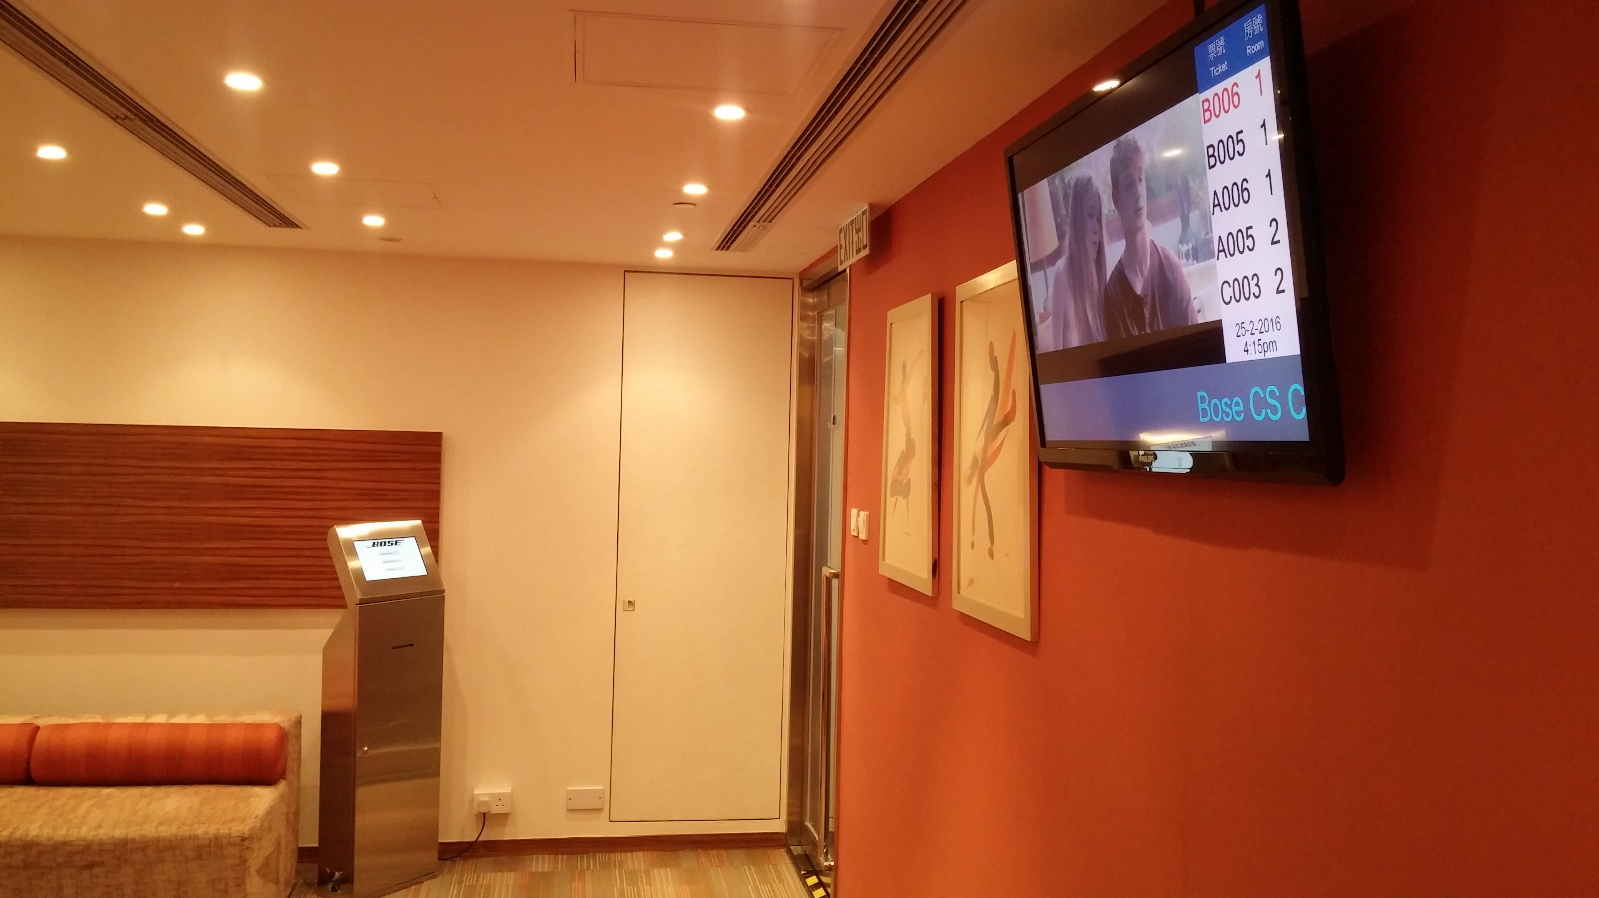

**Client: FTLife Insurance Company Limited**

Location: 31/F Tower 6 The Gateway

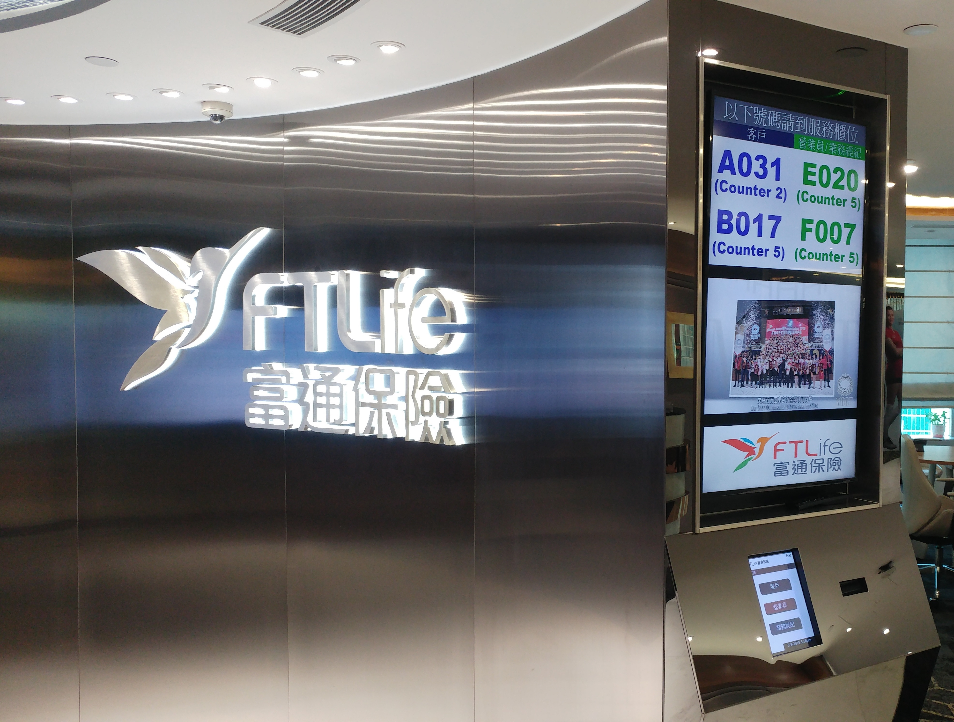

**Client: Saizeriya Italian Restaurant (**薩利亞意式餐廳**)**

All branches in Hong Kong

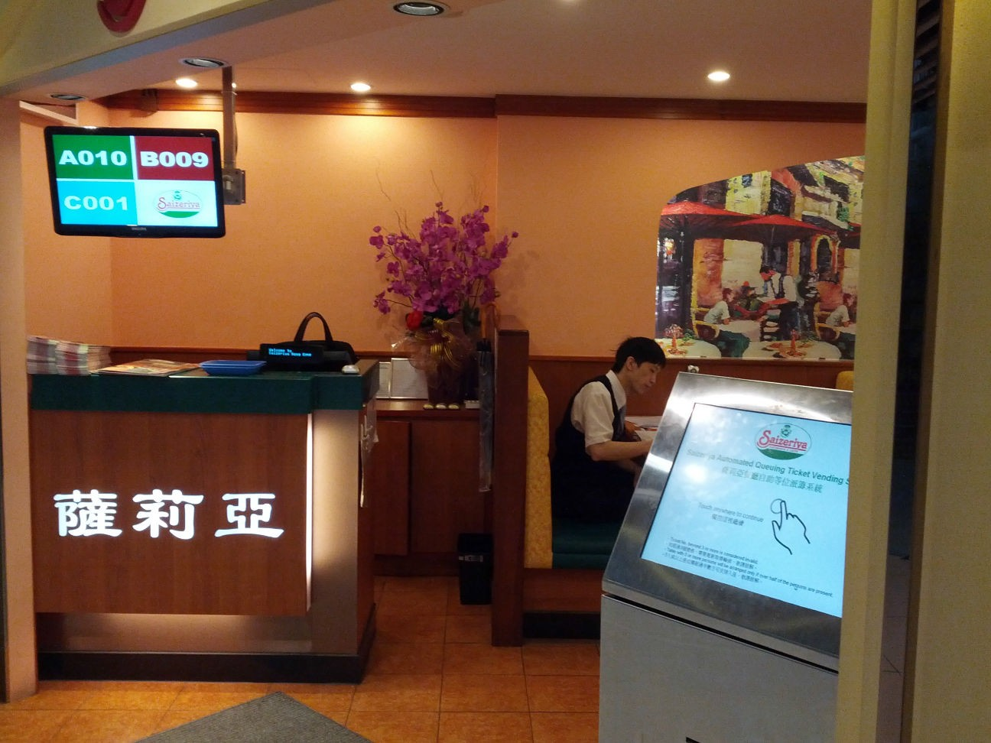



**Client: Prime Credit Limited (**安信信貸有限公司**)**

Location 1: PrimeCredit Limited 8/F, Eurotrade Centre, 21-23 Des Voeux Road, Central, Hong Kong. Location 2: PrimeCredit Limited 3/F, Manson House, 74-78 Nathan Road, Tsim Sha Tsui, Kowloon. Location 3: PrimeCredit Limited 2/F, Ying Hong House, 2 Yeo Wo Street, Causeway Bay, Hong Kong.

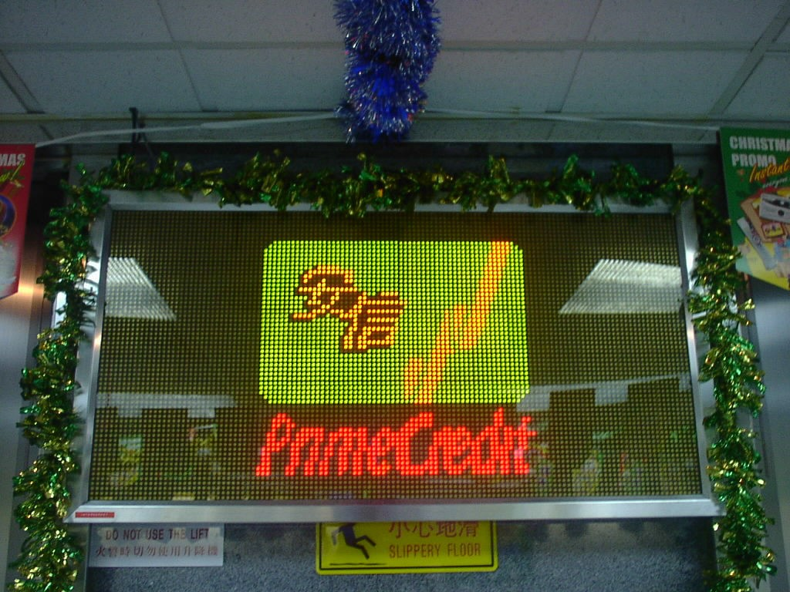

# Client: Shun Hing Technology Co. Ltd. (Sole Agent for Panasonic/National)

## 信興科技有限公司 **(**樂聲牌港澳區總代理**)**

Location : 9th Floor, Peninsula Centre, 67 Mody Road, Tsimshatsui East, Kln., Hong Kong

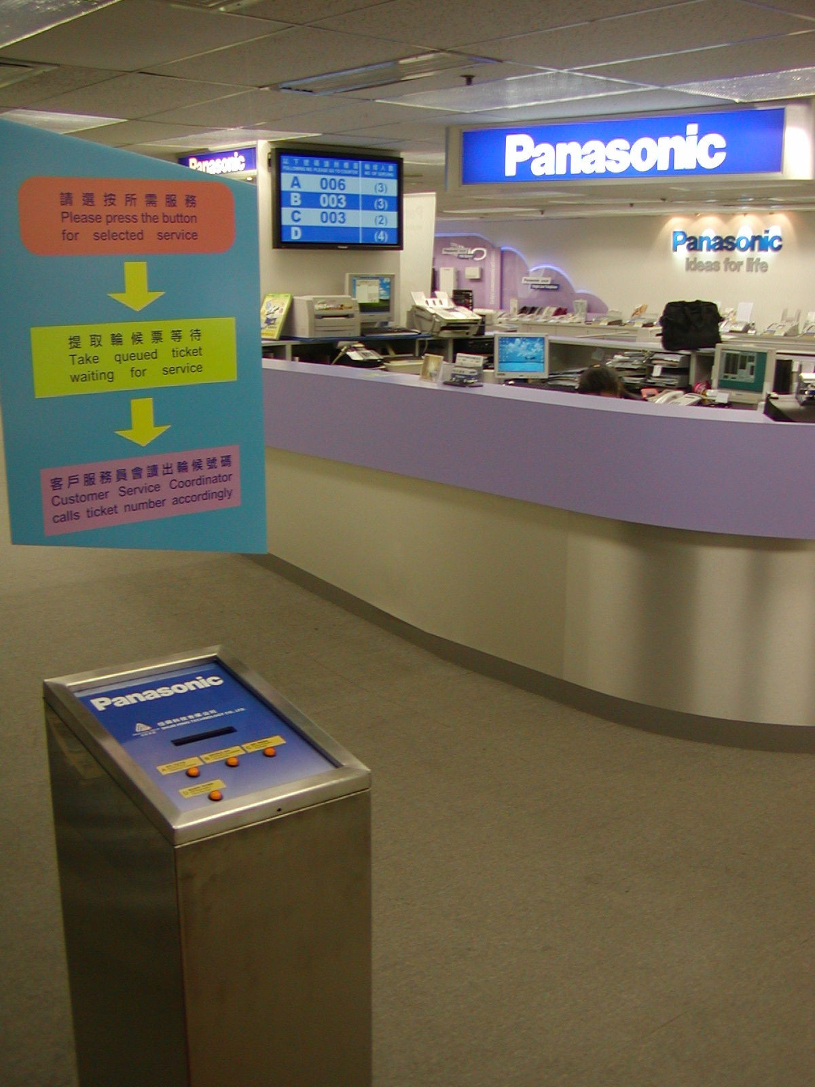

# Client: Besta Technology (HK) Company Limited (好易通科技香港有限公司)

Location : 601, Silvercord Tower 1, 30 Canton Road, T.S.T., Kowloon, Hong Kong

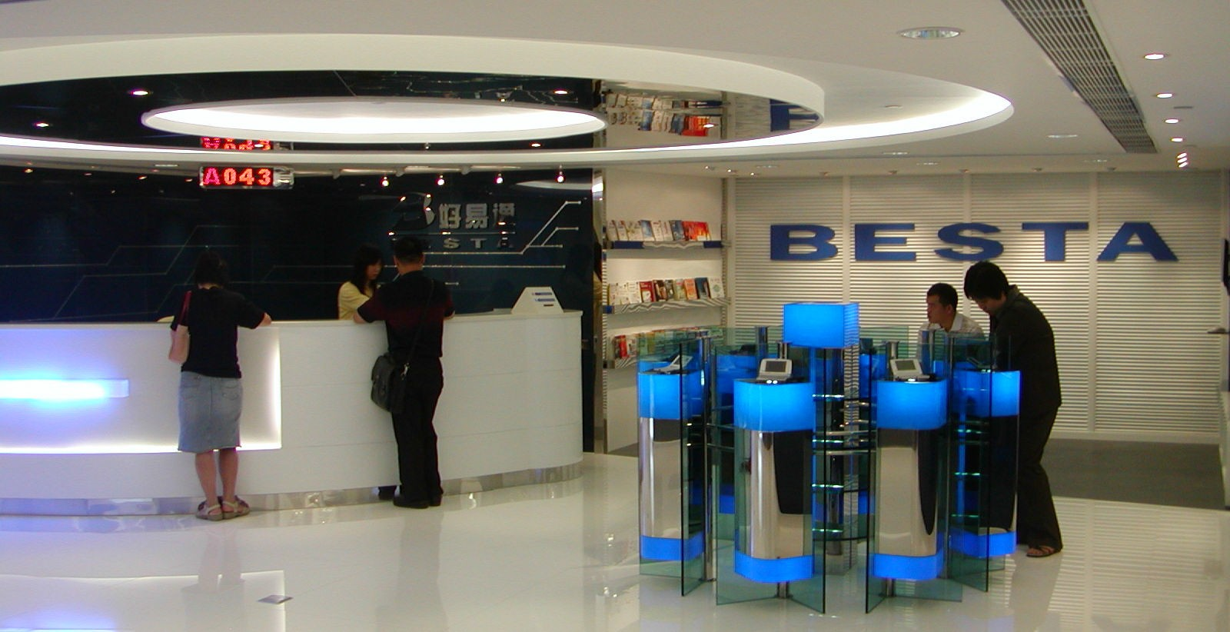

# Client: Hong Kong Public Libraries Leisure and Cultural Services Department (The Government of HKSAR)

## Location: 3/F, 66 Causeway Road, Causeway Bay, Hong Kong.



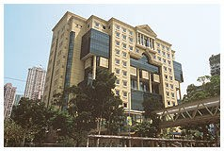

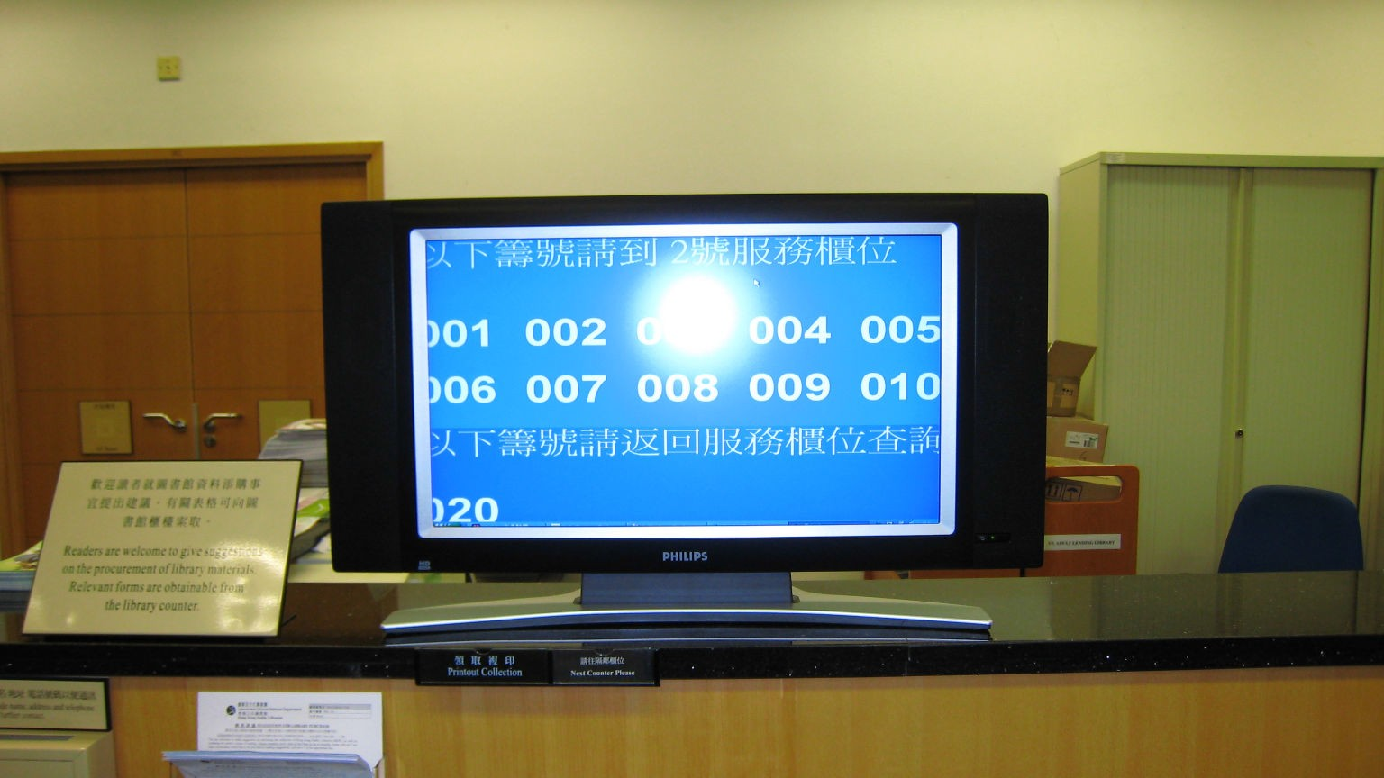

**Client: Crown Motors Limited**

Location 1: North Point, Block B & C, G/F Seaview Estate, 2-8 Watson Road, North Point, Hong Kong

Location 2: Kowloon Bay, G/F, New Bright Industrial Building, 11 Sheung Yuet Road, Kowloon Bay, Hong Kong

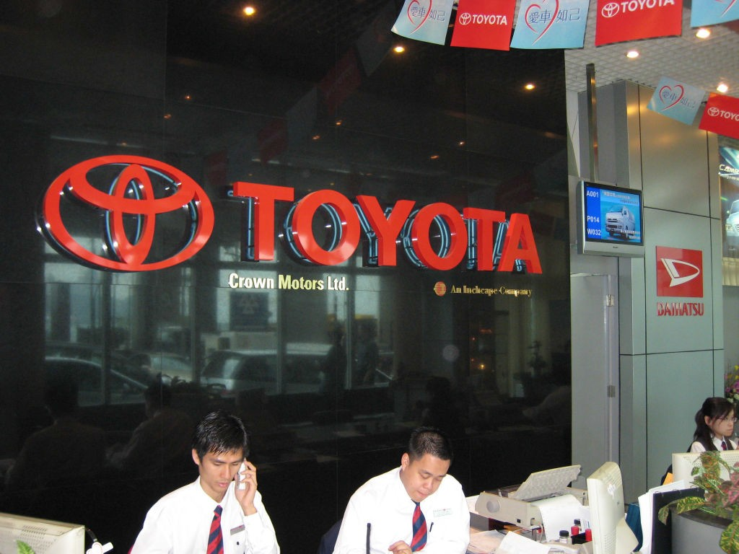 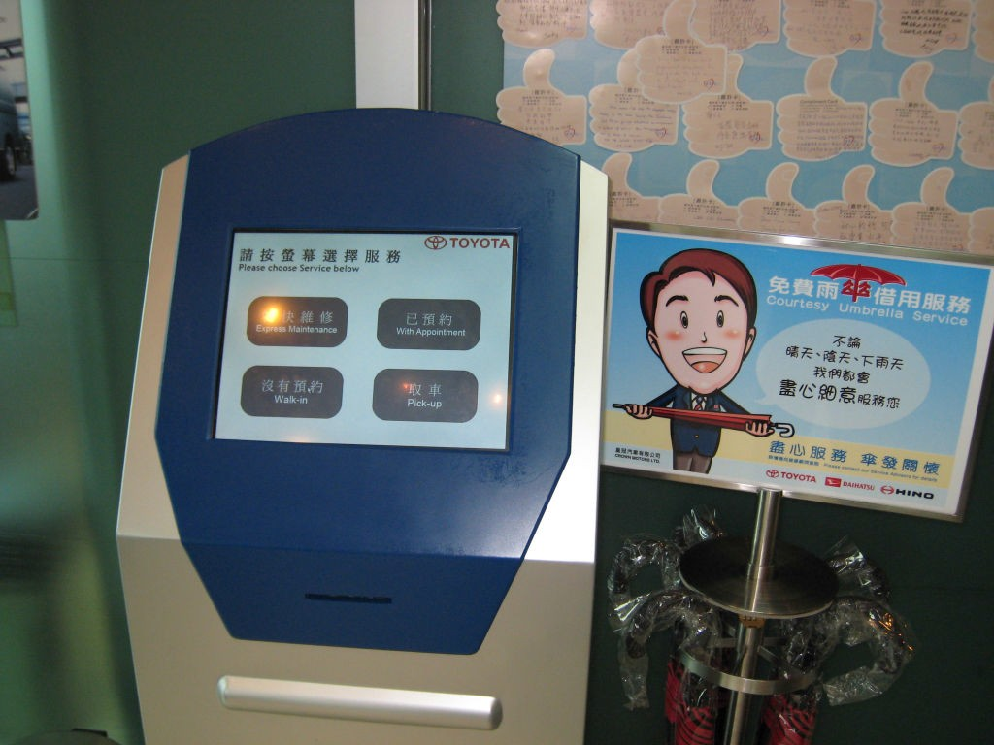

# Client: HKU SPACE

## Location: Kowloon East Campus, 1/F, 28, Wang Hoi Road, Kowloon Bay



**Client: Quality Healthcare Medical Center**

Location: Shop 18, G/F, Tung Chung Crescent, 1 Hing Tung Street, Tung Chung, Lantau

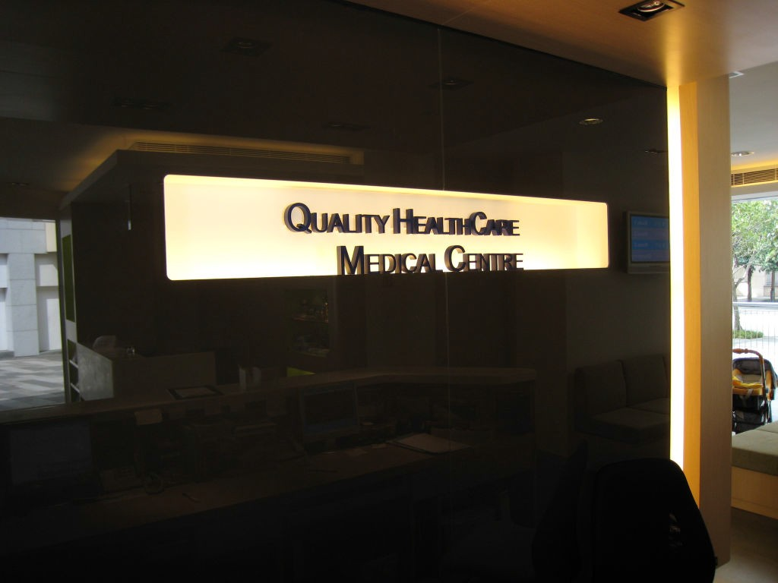 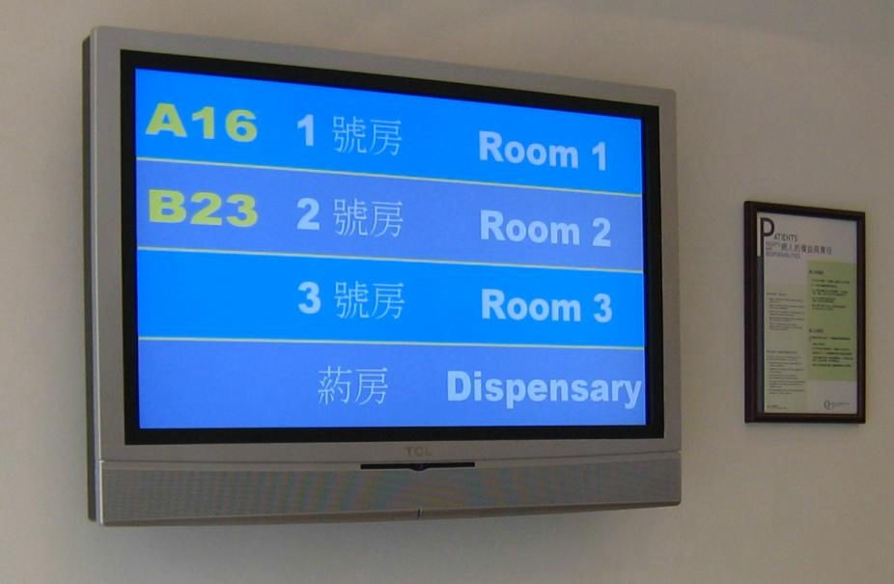

# Client: Fortis Asia Holdings Limited

Location 1: 27/F, Wing On Centre, 111 Connaught Road Central, Hong Kong

Location 2: Level 31, Office Tower, Langham Place, 8 Argyle Street, Mongkok, Kowloon Location 3: 22/F, Fortis Centre, TaiKoo MTR A

 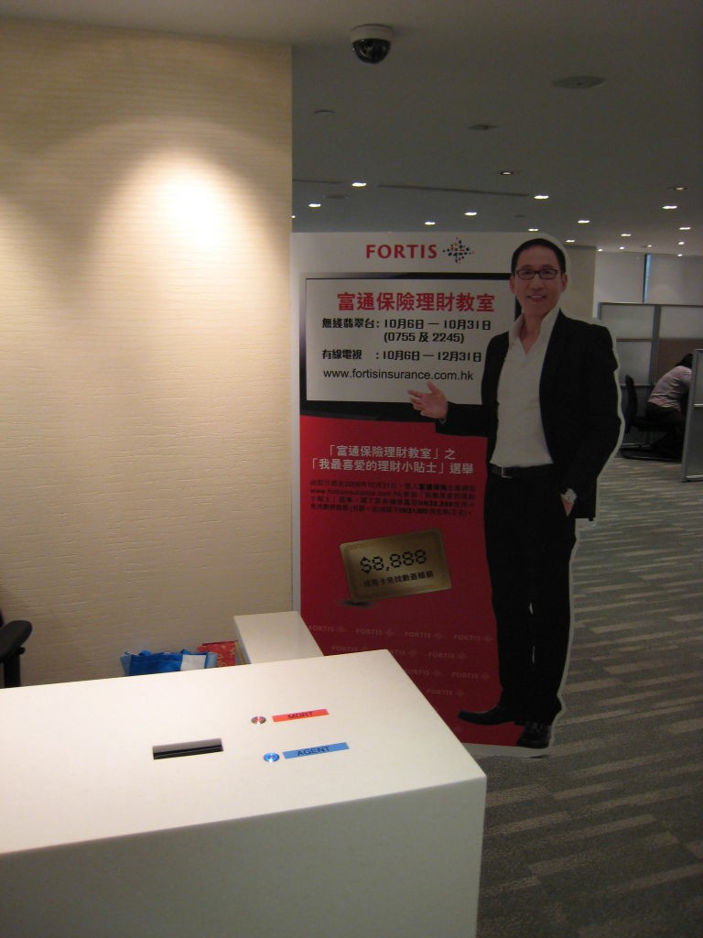

# Client: Cathay Pacific Airways Limited

**Location:** Suite 1808, 18th floor, Tower 6, The Gateway, Harbour City, 9 Canton Road, TST, Kowloon

 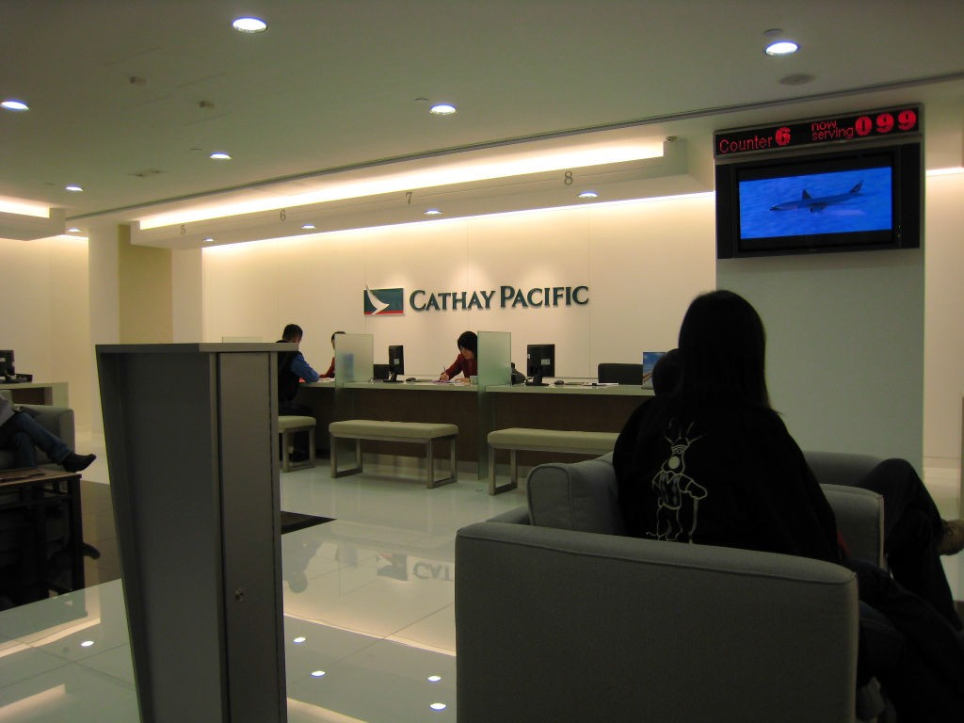

**Client: The Macao Water Supply Co. Ltd.**

Location: 718, Avenida do Conselheiro Borja, Macau

 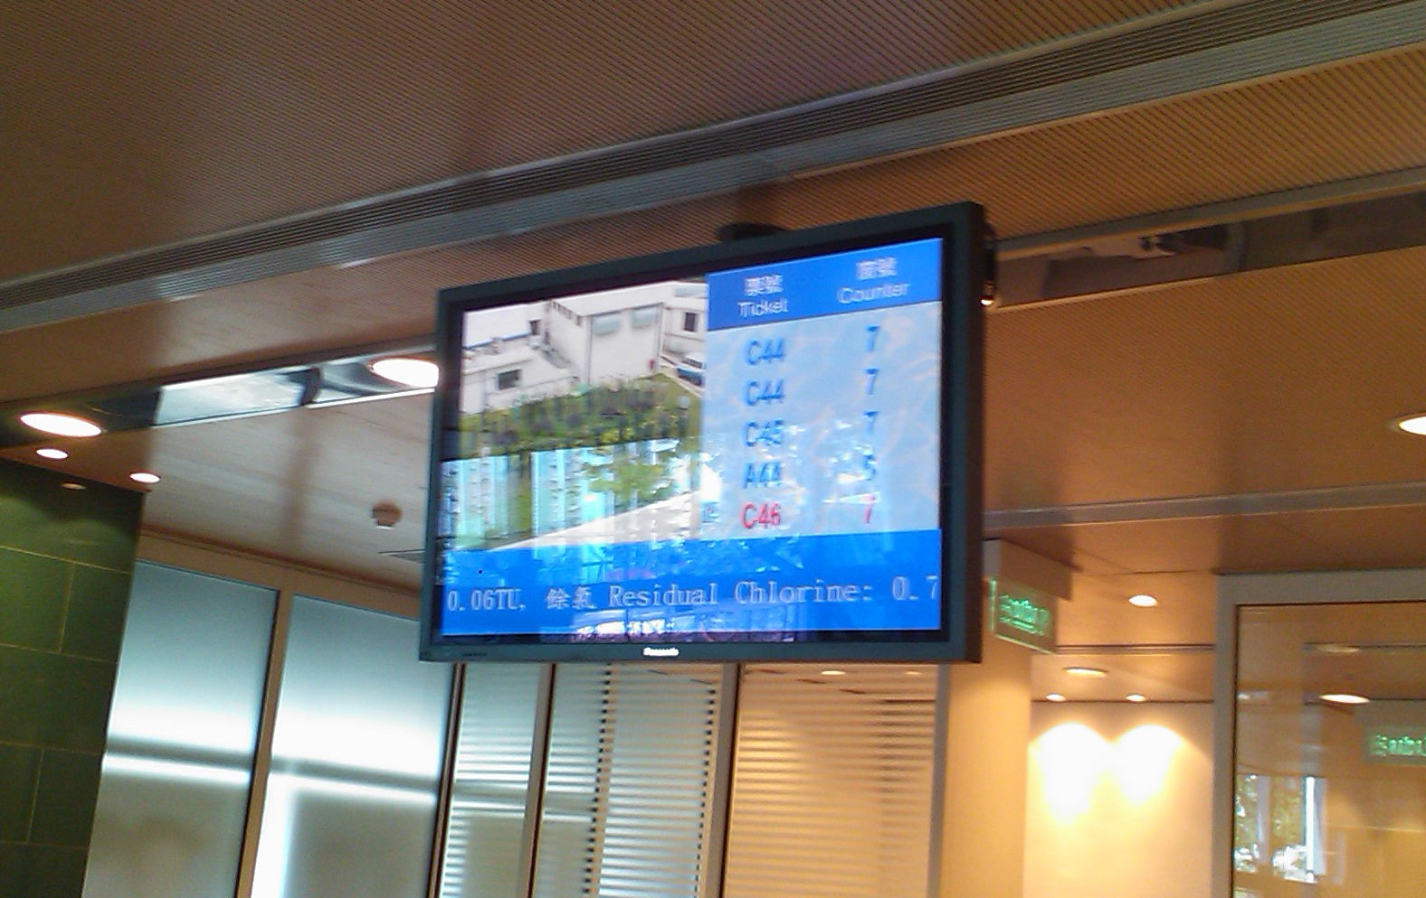

# Client: City Super Ltd.

Location 1: IFC shopping mall, Central, Hong Kong Location 2: Times Square, Causeway Bay, Hong Kong Location 3: APM, Kwun Tong, Kowloon

Location 4: Harbour City, TST



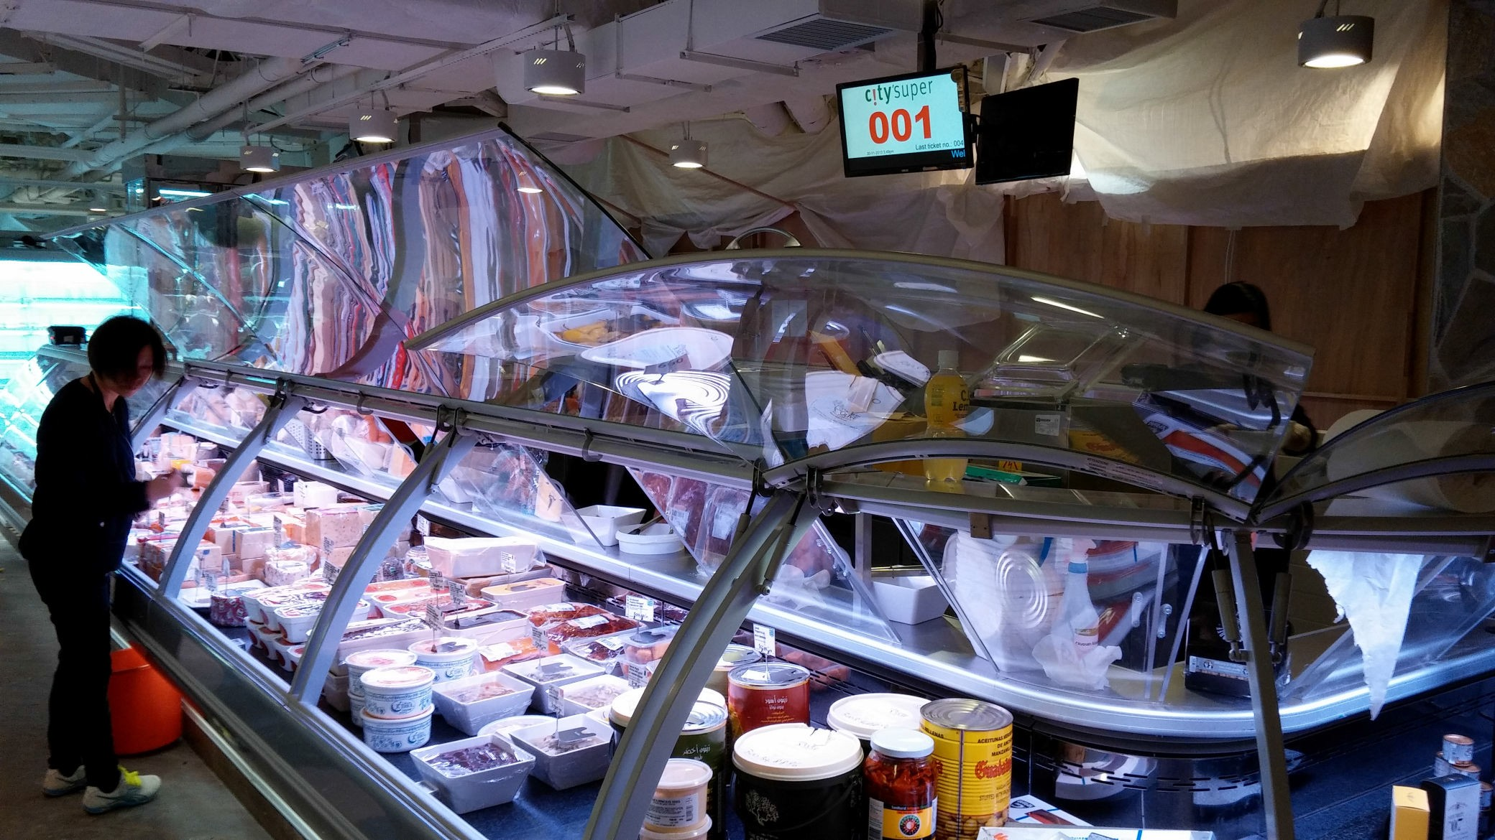

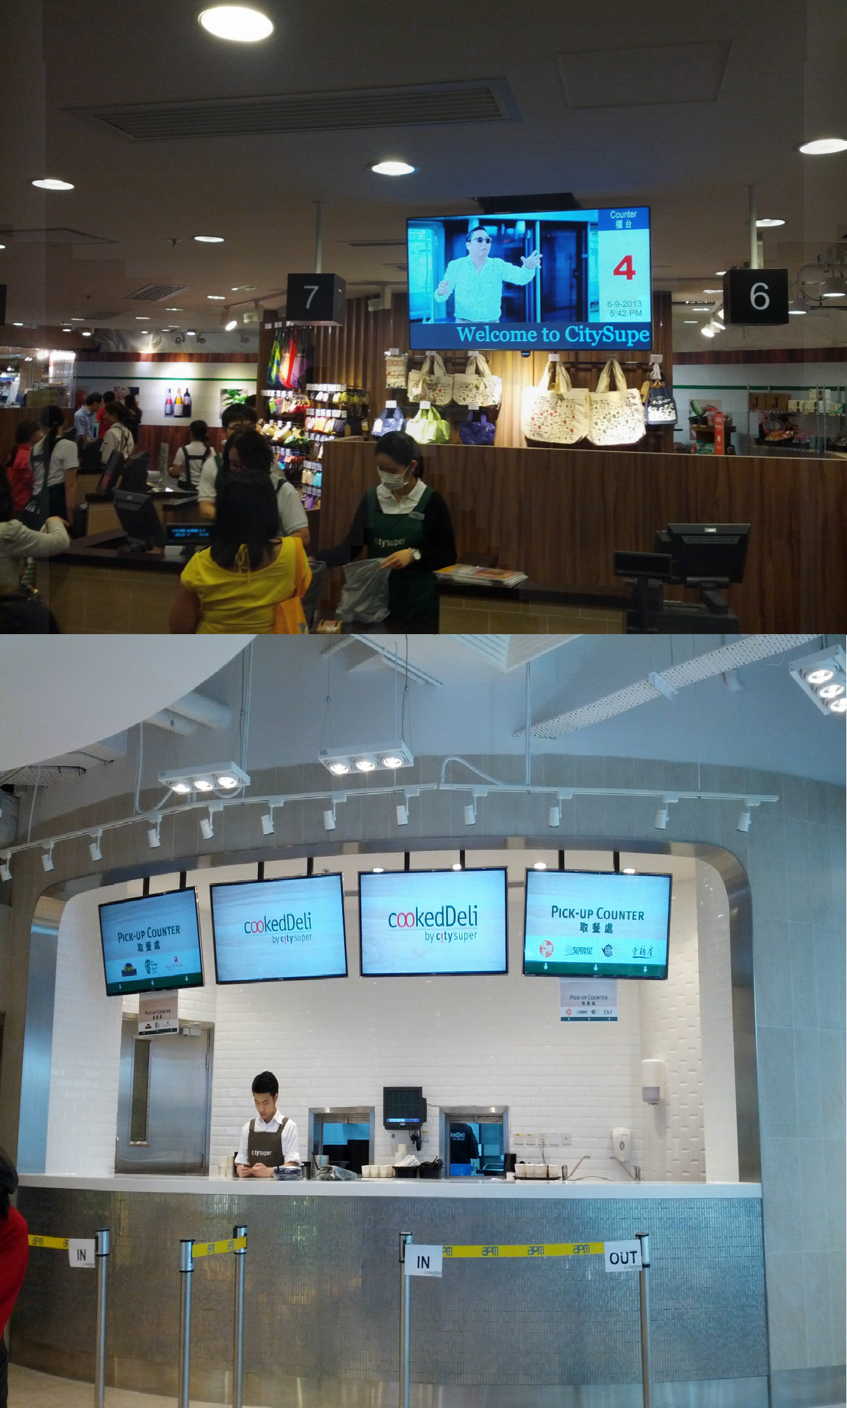

**Client: Hong Kong International Airport (**香港國際機場**)**

Location: Departures East Hall, Hong Kong International Airport, Lantau, Hong Kong

 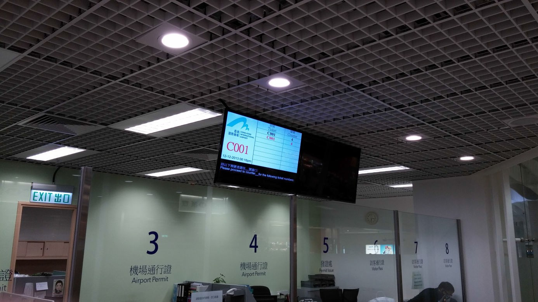

**Client: IKEA (**宜家家居**)**

Location: 4/F, Megabox, Kowloon Bay, Kowloon (Smaland)

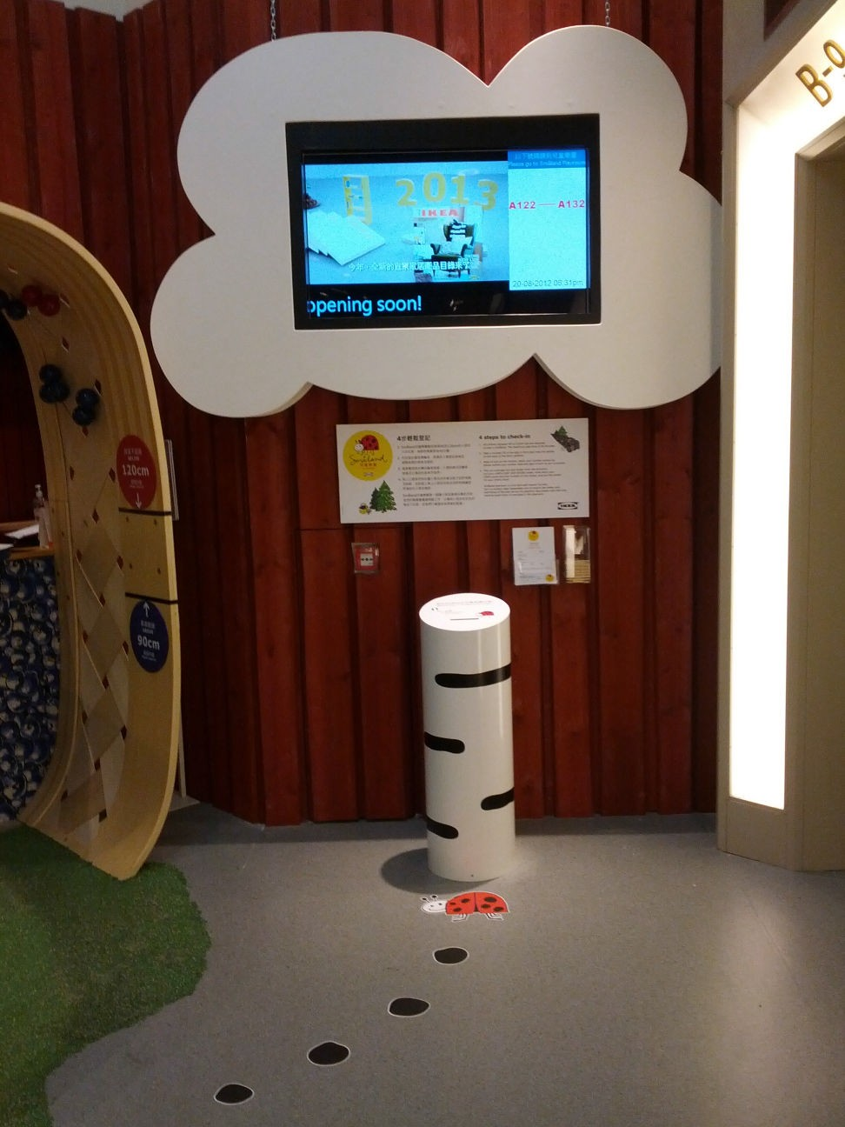



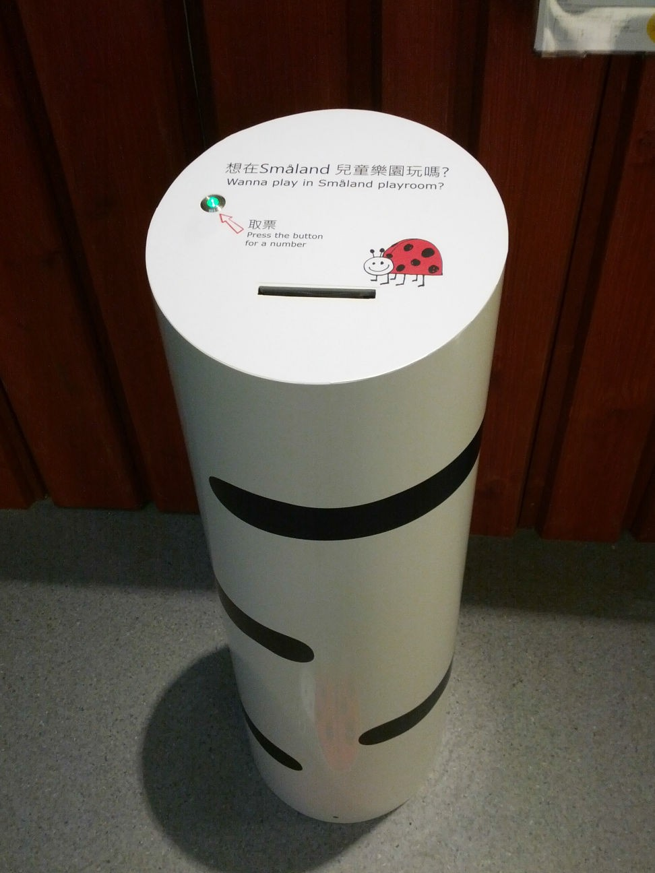

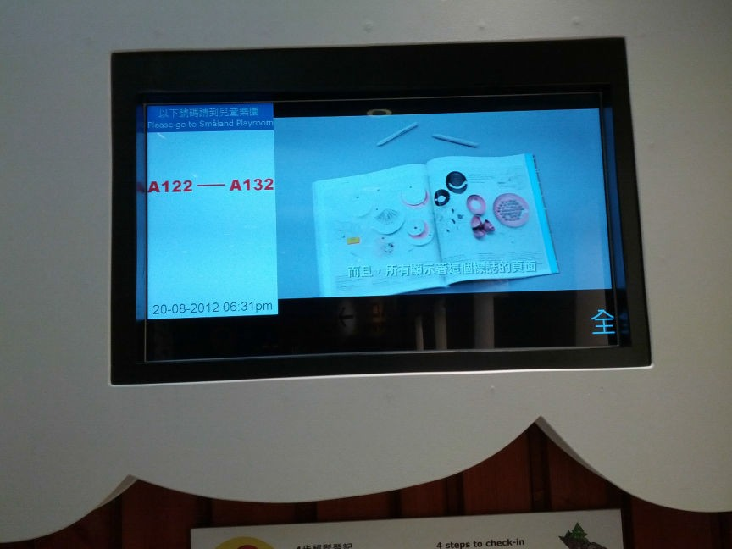

# Client: Labour Department (The Government of the HKSAR)

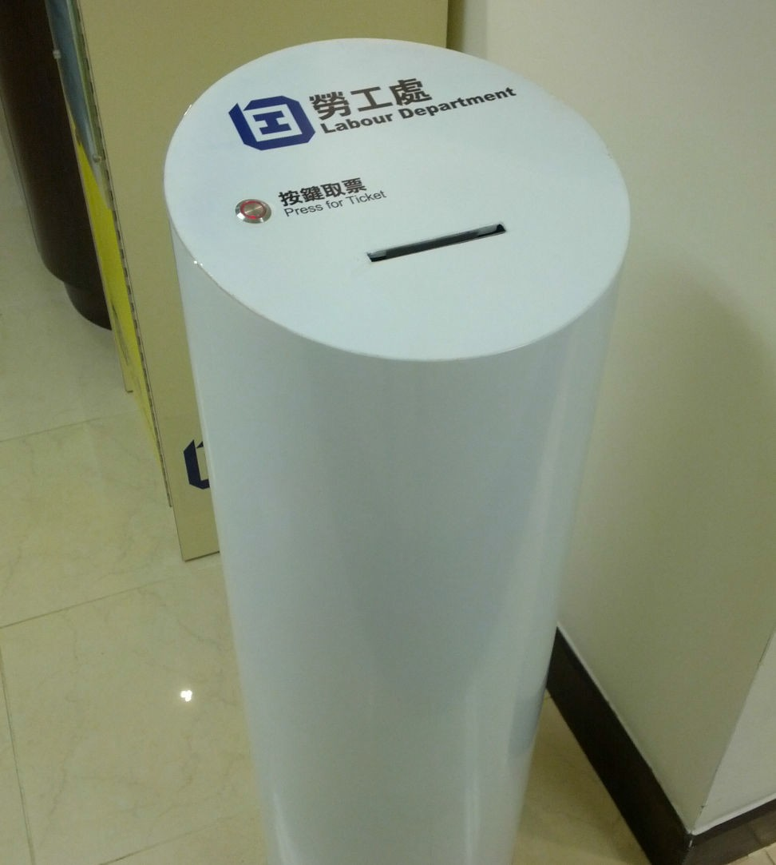

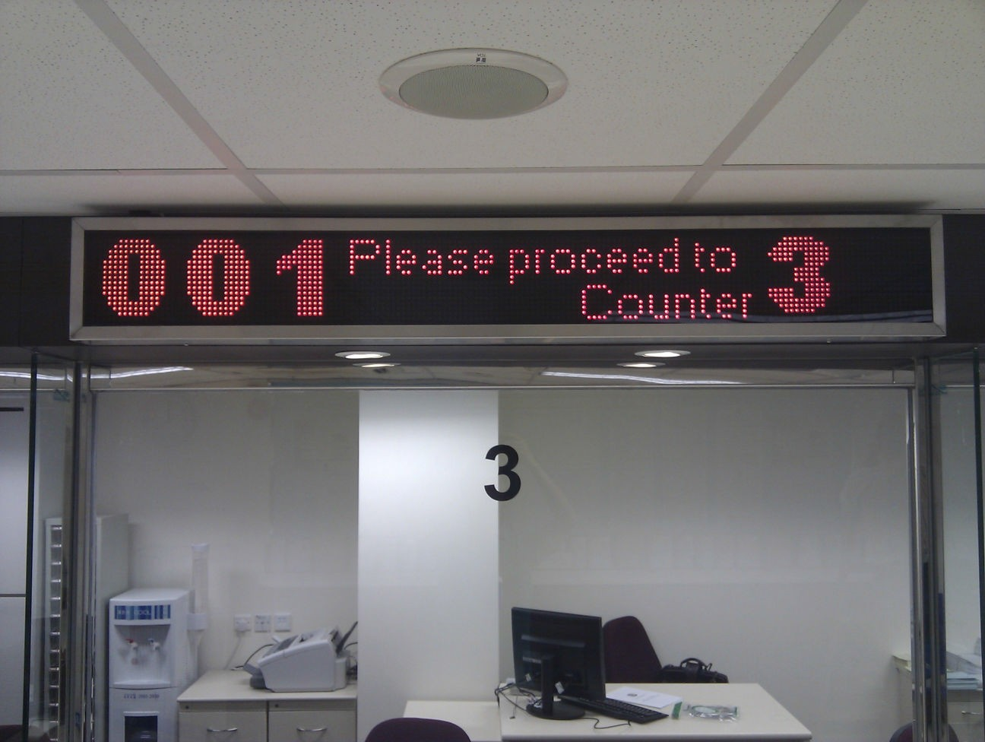

## 勞工處 **(**香港特別行政區政府**)**

Location: Unit 1225, 12/F, KITEC,1 Trademart Drive, Kowloon Bay, Kowloon



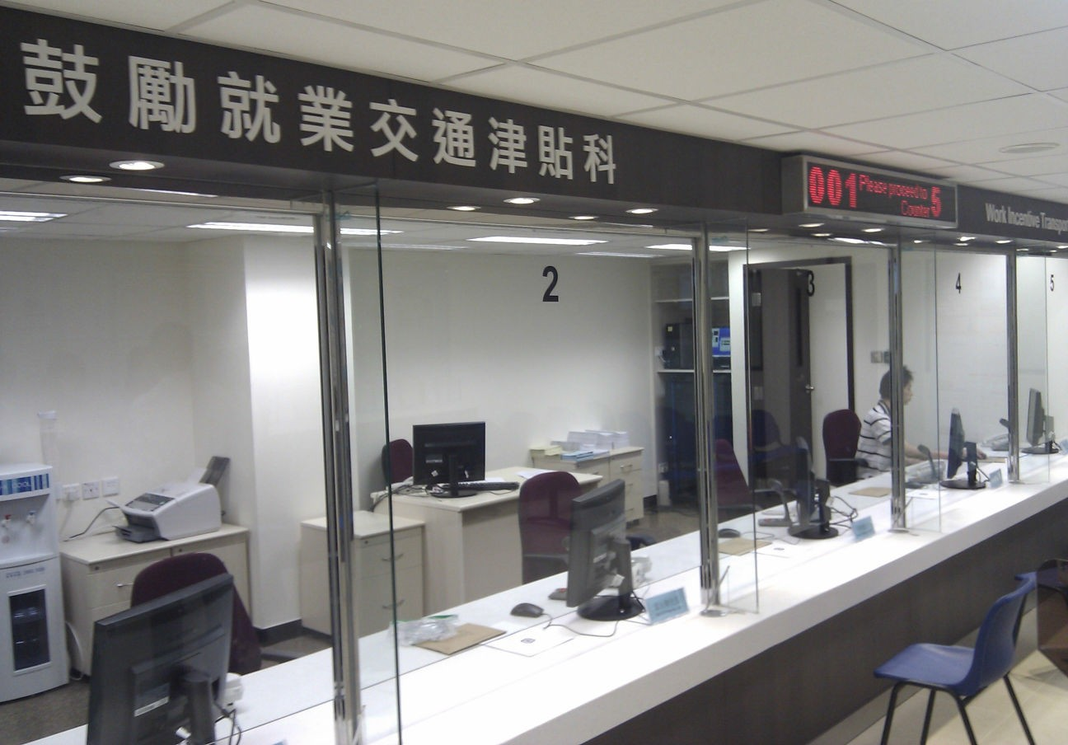 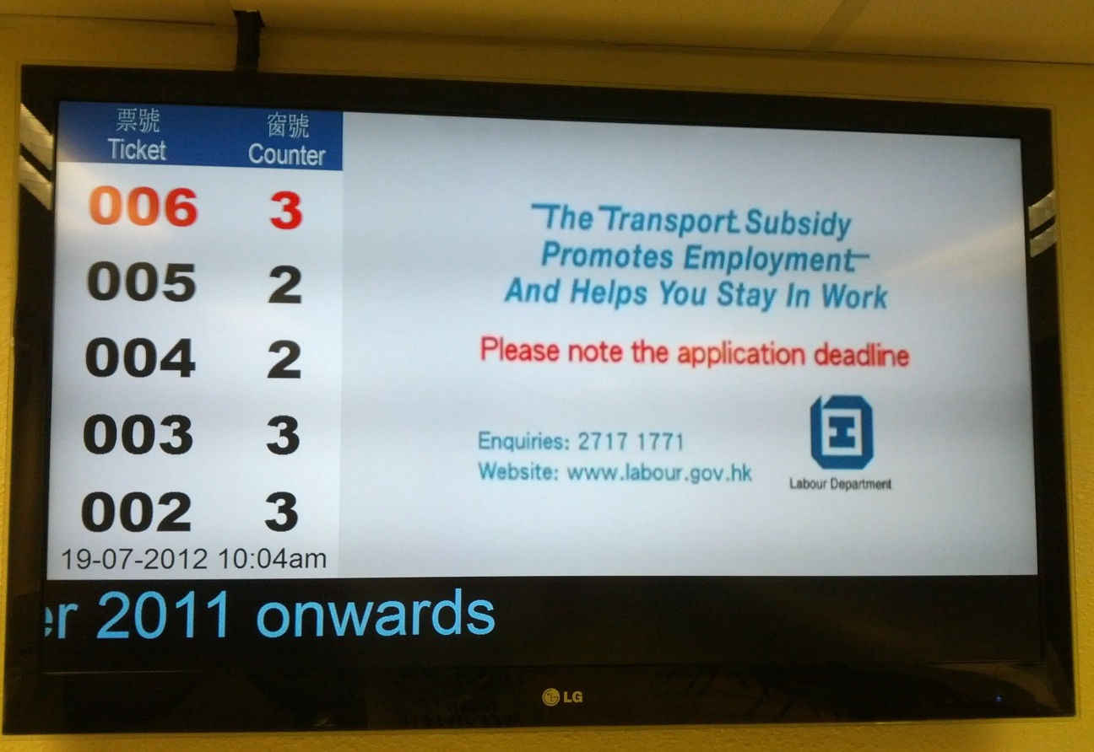

**Client: Pizza Hut Hong Kong**

Location 1: Shop 3, G/F & 1-2/F, Mongkok Plaza, 28 Soy Street, Mongkok Location 2: 1/F, 655 Nathan Road, MongKok

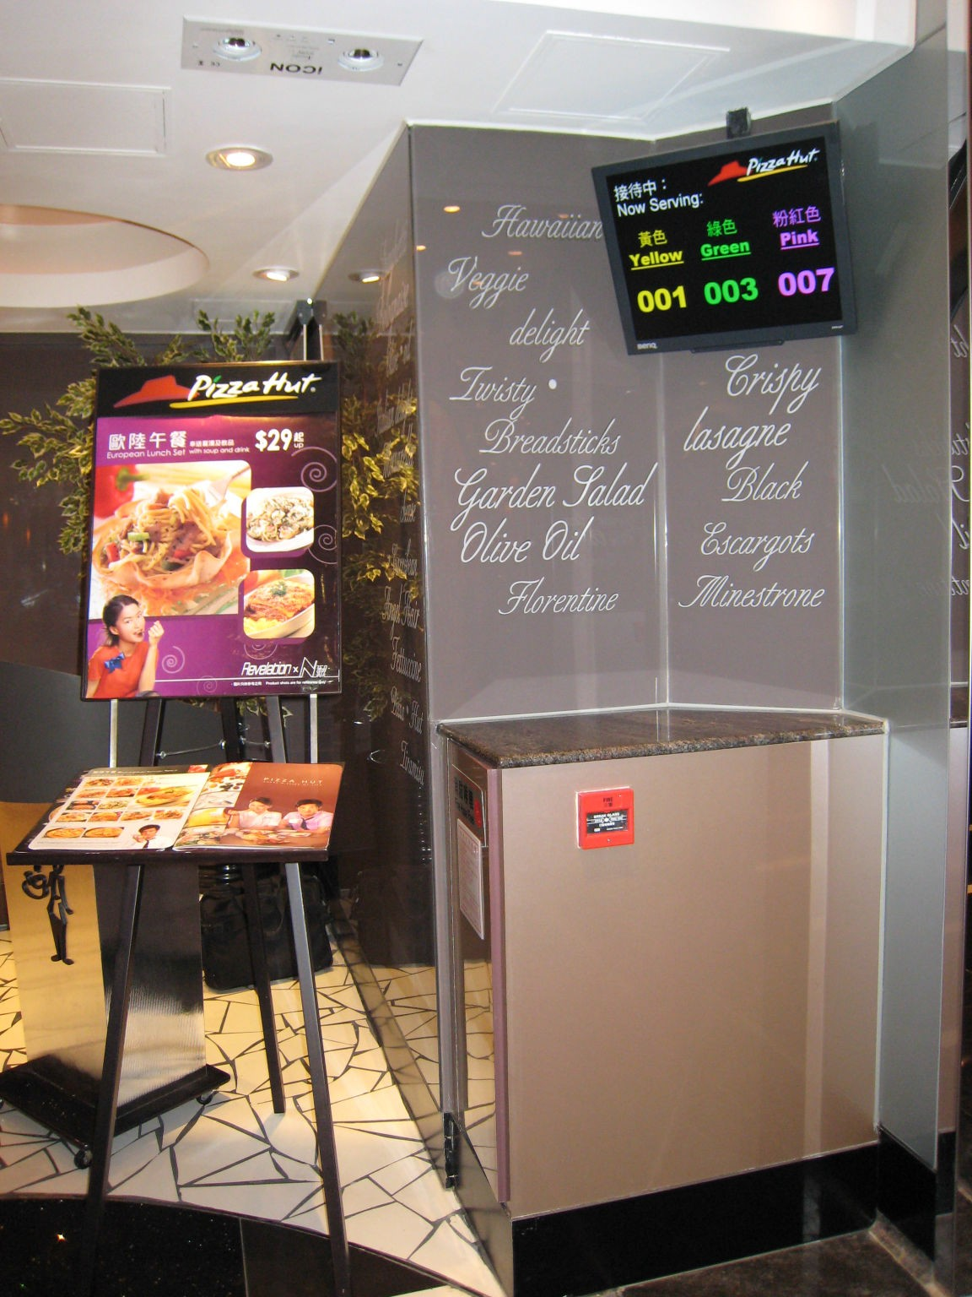



# Client: Ocean Park

Location 1: Panda restaurant Location 2: Ocean restaurant



# Outdoor LED Traffic Sign Project

**Client: New Hong Kong Tunnel Co. Ltd.(Operator of Eastern Harbour Tunnel)**

## 新香港隧道有限公司 **(**東區海底隧道**)**

Location 1: Eastern Harbour Tunnel, Quarry Bay, Hong Kong Details:

Develop and provides Lane Control Signal LED Signs (LCSS). The LCSS made by outdoor Super Bright 28mm LED cluster module (6 red and 3 pure green). To display the Cross, Forward arrow, Left arrow or Right arrow controlled by control Server at New Hong Kong Tunnel Company Ltd.'s Administration Building.Two levels dimming control function (day and night). Our products approved by Transport Department.

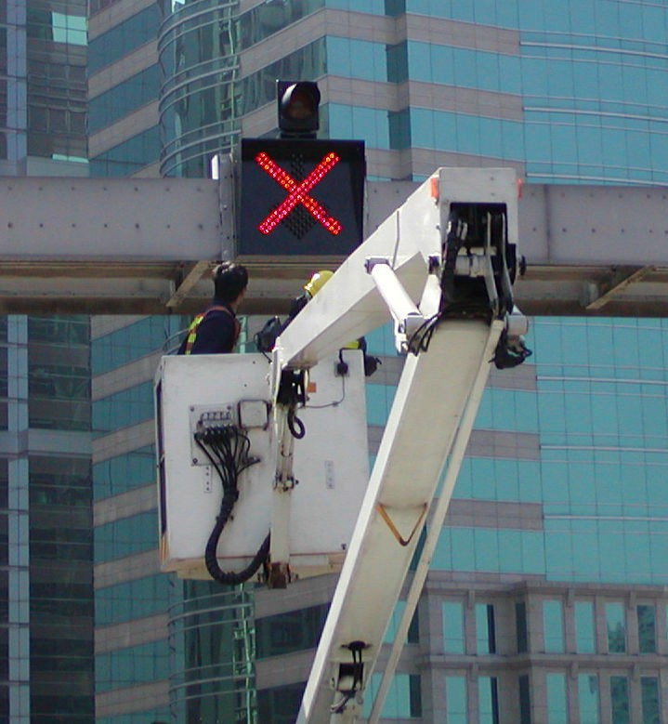

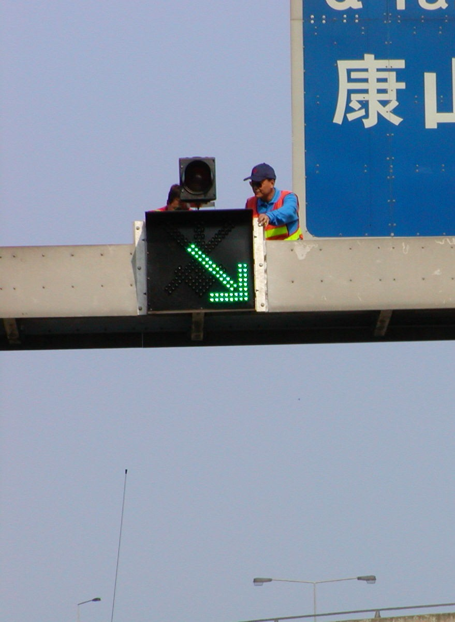

# Client: Asia Airfreight Terminal Co. Ltd. (亞洲空運服務有限公司)

Location: 10 Chun Ping Road, Hong Kong International Airport Lantau, Hong Kong Details:

Develop and provides LED Dot Matrix Display Board. It is made by Outdoor super bright 28mm cluster LED module (Amber). 3 Groups LED display area, each area max. Show 3 Digit / Alphabet char. (Digit

/ Alphabet Height 7", Chinese Height 8")

Dimension of the Plate size is 3500mm (w) x 2500mm (h).

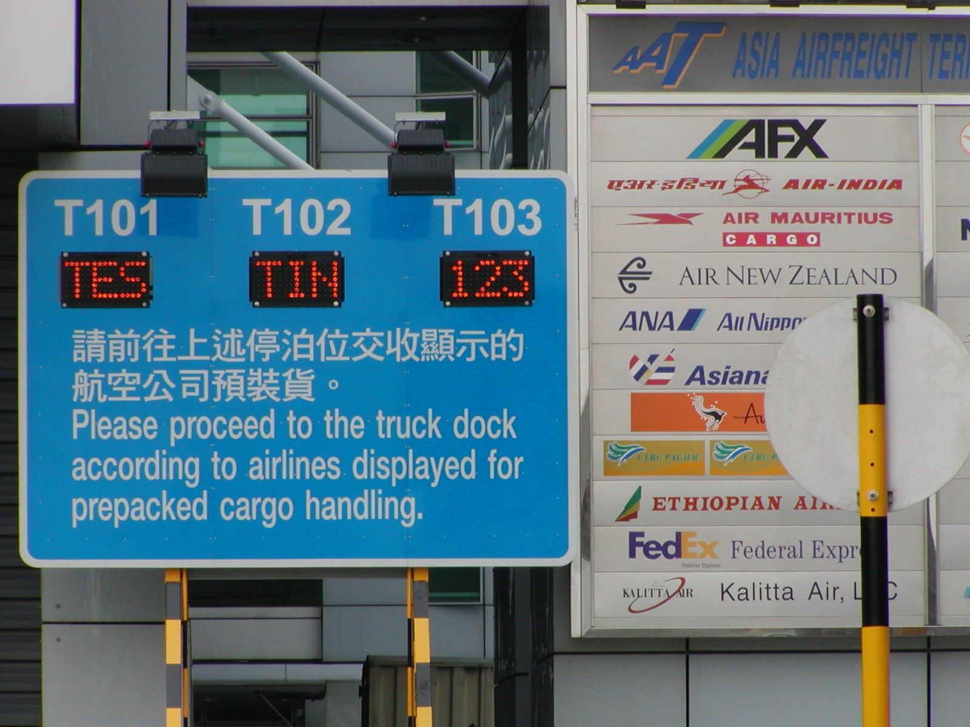

# GPRS LED Display Board Project

**Client: Transport Department (The Government of the HKSAR)**

## 運輸處 **(**香港特別行政區政府**)**

Location: Hung Hom Railway Station.-Transport Department, HKSAR

GPRS is a new technology makes it possible for users to upload data in mobile telephone or personal computer and transmit data at the same time. It contains more advantages, such as 'Highly Flexibility', 'Use Everywhere'. 'Operation on time', 'always-online', higher capacity', High-speed Transmission', 'Change Freely'. Easy to use and convenient to update the data, especially for fulfill the LED Display Board long distant control.

Dot matrix LED display board, Amber Resolution 256 (w) x 64 (h) dots (64 BLKS) Screen size ~1024mm (w) x 256mm (h)

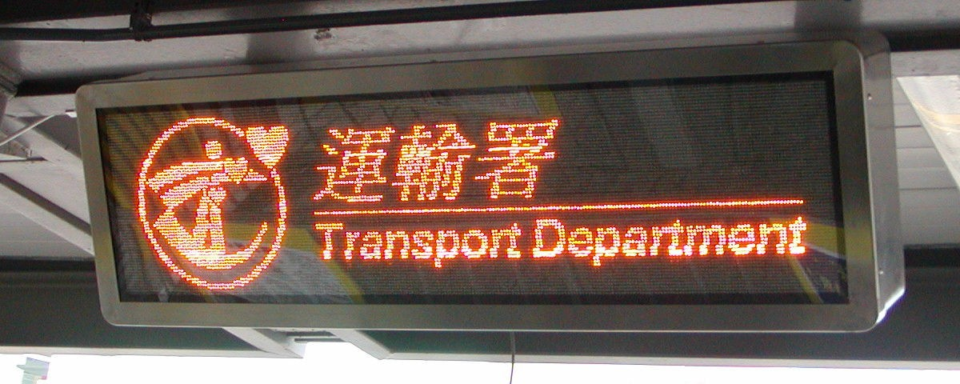

# Outdoor LED Project

**Client: CNPC (Hong Kong) Limited** 中國**(**香港**)**石油有限公司

Location 1: Chung Yan Road, Tong Chung, Lantau Island Location 2: Po Hong Road, Tseung Kwan O, N.T. Location 3: Yeung Uk Road, Tseun Wan. N.T.

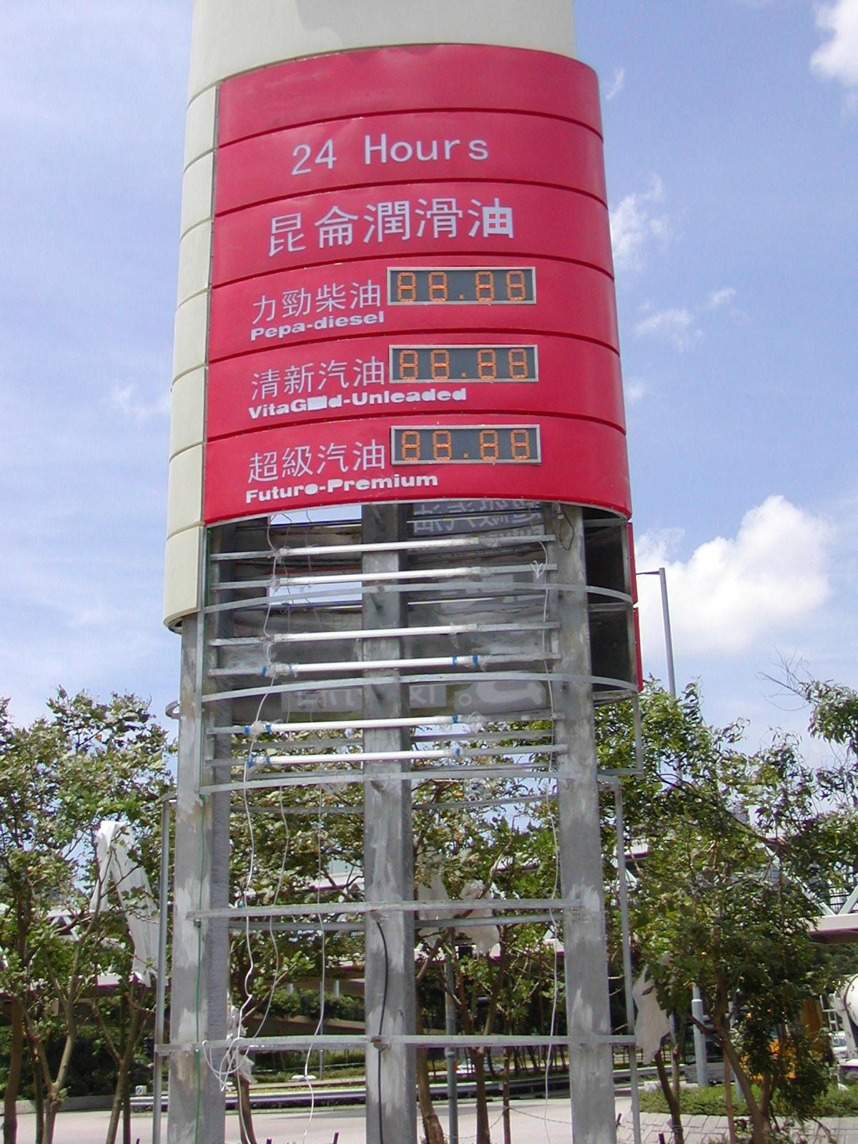

# Outdoor Dot Matrix LED Project

**Client: Bank of China Group Insurance Company Limited**

## 中銀集團保險有限公司

Location: Bank of China Insurance Building, 136 Des Voeux Road Central, Hong Kong Dot matrix LED display board, Tri colours,

Resolution 800 (w) x 16 (h) dots (50 BLKS), Screen size ~12800mm (w) x 256mm (h).

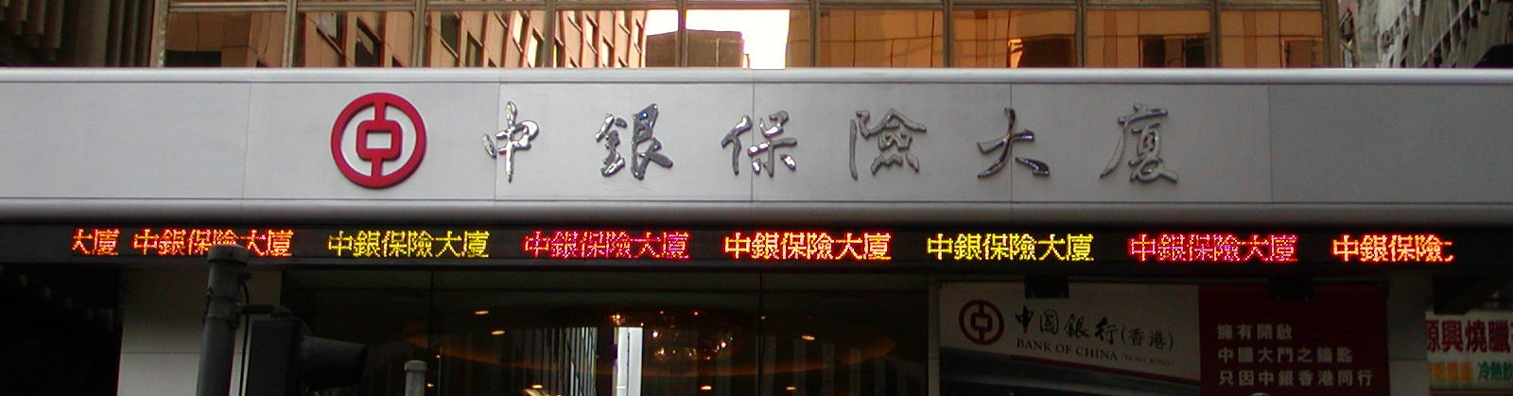

# Indoor Dot Matrix VGA Project

**Client: Hong Kong Cable Television Limited (**香港有線電視有限公司**)**

Location: Cable TV Tower, 9 Hoi Shing Road, Tsuen Wan, Hong Kong

Dot matrix LED display board, 7133300 colours, Resolution 160 (w) x 256 (h) dots (160 BLKS), Screen size ~1220mm (w) x 1950mm (h).

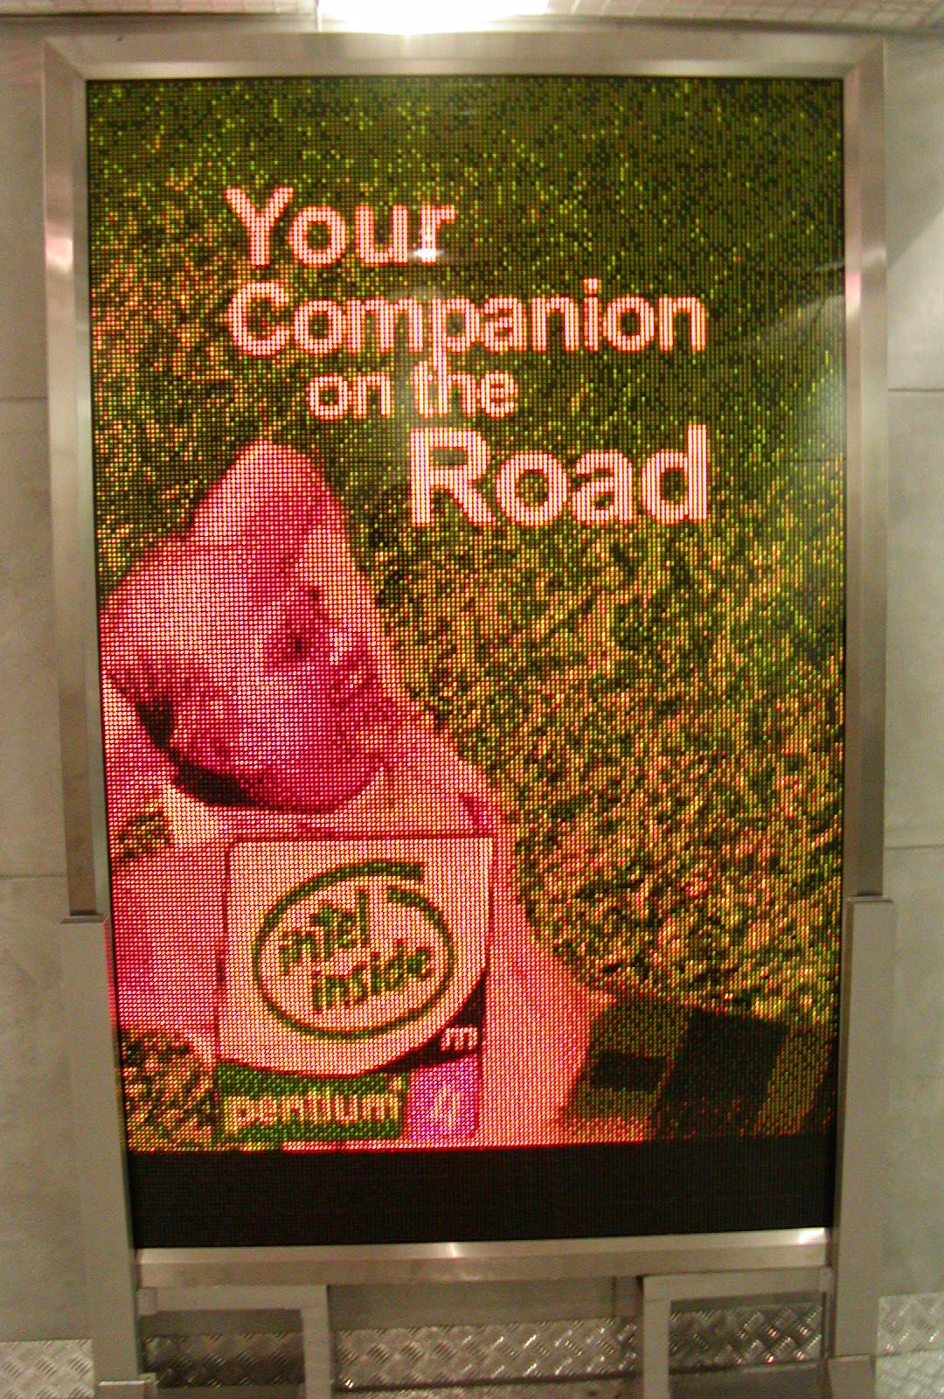

# Others Outdoor & Indoor LED board Project

## Dot matrix LED display board, Amber colours, Resolution 192 (w) x 96 (h) dots (72 BLKS), Screen size ~1464mm (w) x 732mm (h).



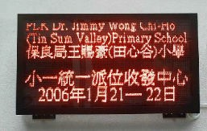

**Client: Asia Pacific Catering Corporation Limited (**泛亞飲食有限公司**)**

Location: Hong Kong International Terminals (HIT) Location: United Christian Hospital

Location: Nethersole Hospital Location: Science Park Location: HAESL

**Client: Super Super Congee & Noodle (**一粥麵**)**

Location: 338 3/F WongTai Sin Commercial Complex,Wong Tai Sin, Wong Tai Sin Location: Shop No. 61,62,67-68, 1/F, Ngan Shing Plaza, City One, Shatin Location: Shop 239, 2/F, Sheung Tak Shopping Centre, Tseung Kwan O

Client: Next Media Management Services Limited (壹傳煤管理服務有限公司)

Location: 8 Chun Ying Street T.K.O Industrial Estate West, Tseung Kwan O

**Client: SAR Culture Ltd. (**開益書店**)**

Location: 1/F 511 LockHart Road, Causeway, Hong Kong. Location: 1/F 45 Haiphong Road, Tsim Sha Tsui, Kowloon.

**Client: Tin Wan Chi Nam Pri School (**聖公會田灣始南小學**)**

Location 4: Tim Wan New Street, Aberdeen, HongKong.

**Client: Y.L.P.M.S. Alumni Assn. Primary School (**元朗公立中學校友會小學**)**

Location: No. 2, Town Park Road North, Yuen Long, N.T.

**Client: Y.L.P.M.S. Alumni Assn. Ying Yip Primary School (**元朗公立中學校友會英業小學**)**

Location: No.86, Tin Shui Road, Tin Shui Wai, N.T.

**Client: PLK Dr. Jimmy Wong Chi-Ho (Tin Sum Valley) Pri. School (**王賜豪**(**田心谷**)**小學**)**

Location: No.2A, Lung Hang Estate, Shatin, N.T.

**Client: PLK Fung Ching Memorial Primary School (**保良局馮晴紀念小學**)**

Location: No.2, Pui Shing Road, Tseung Kwan O, N.T.

**Client: St. Barnabas' Church (**聖公會聖巴拿巴堂**)**

## Location: No.71, Shui Wo Street, Kwun Tong, Kowloon,Hong Kong.

**Client: Tsang Fook Piano Co. Ltd. (**曾福琴行**)**

Location: UG/F, Eaton Hotel , Nathan Road, Kowloon Hong Kong

**Client: Abbott Labs Ltd. (**美國雅培製藥有限公司**)**

## Location: 20/F AIA Tower, North Point, Hong Kong.